E-Clips
The E-Clips is a no nonsense lockback that is lightweight, durable and affordable. The first thing you might notice is our (patent-pending) adjustable thumbstud fine tune its position and tailor it to your hand. Appreciate the signature basket weave texture, which insures non-slip performance. The blades are beautifully ground with a two directional high gloss satin finish, typically only found in much more expensive knives.

Key Selling Features:
- Key chain knife with pocket clip
- 2-inch satin polished 420 stainless steel blade
- Glass-reinforced Nylon handle
- Pocket Clip and Key Ring Clip
- Overall length: 4.75-inches, Weight: .7 ounces, Lifetime Warranty
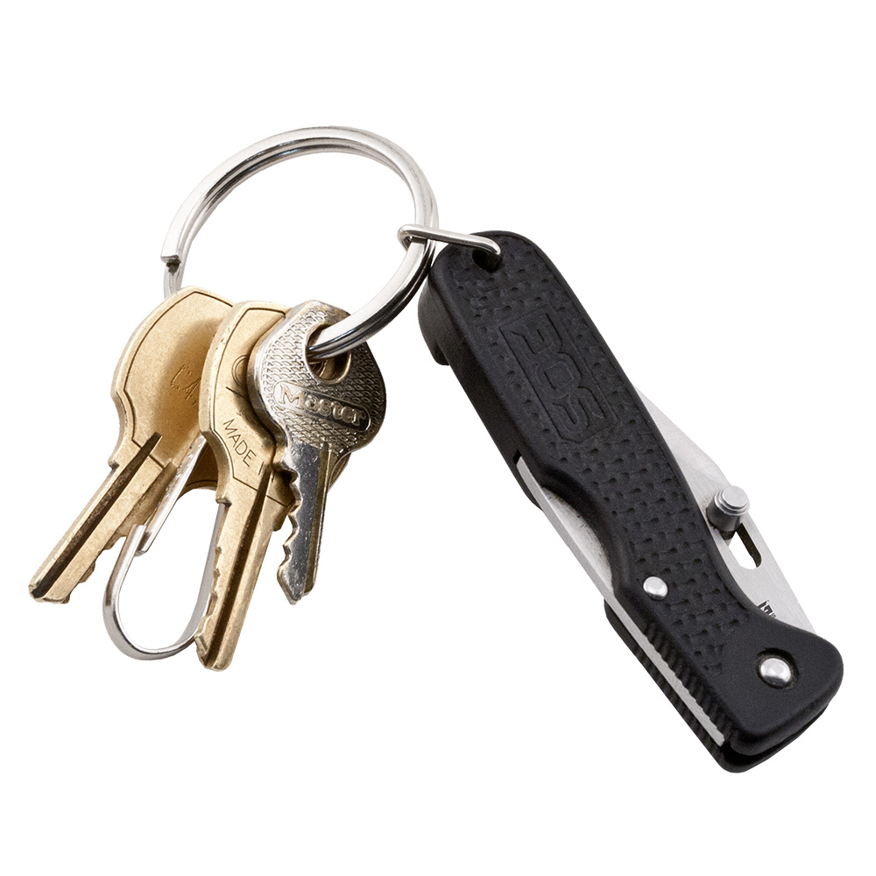
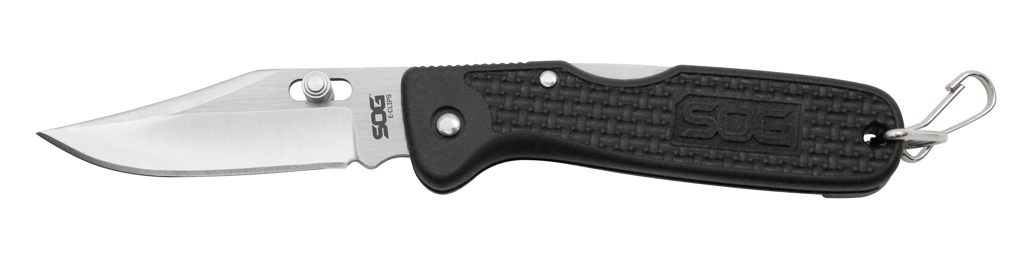
FINISH SATIN POLISHED
BLADE SHAPE CLIP POINT
EDGE TYPE STRAIGHT
BLADE STEEL TYPE 420 STAINLESS
HANDLE MATERIAL GLASS-REINFORCED NYLON (GRN)
HARDNESS RC. 51-53
PRODUCT WEIGHT 0.7 OZ
BLADE LENGTH 2”
CLOSED LENGTH 2.75”
OVERALL LENGTH 4.75”
MODEL NUMBER AC01-CP
UPC 729857994040

