Mini AutoClip
SOG has brought back the AutoClip series, a no nonsense line of lockbacks that are lightweight, durable and affordable. The name comes from our spring-activated clip design, which allows variable thickness pant edges to be treated equally with the proper clamping force. The next thing you might notice is our adjustable thumb stud (patent-pending) fine tune its position and tailor it to your hand. Appreciate the AutoClip’s signature basket weave texture, which insures non-slip performance. The blades are beautifully ground with a two directional high gloss satin finish, typically only found in much more expensive knives. Several sizes and styles are available to fit your many applications.

Key Selling Features:
- Folding knife with Spring tension pocket clip
- 2.86-inch satin polished 420 stainless steel blade
- Glass-reinforced Nylon handle
- Spring tension pocket clip
- Overall length: 6.7-inches, Weight: 1.7 ounces, Lifetime Warranty
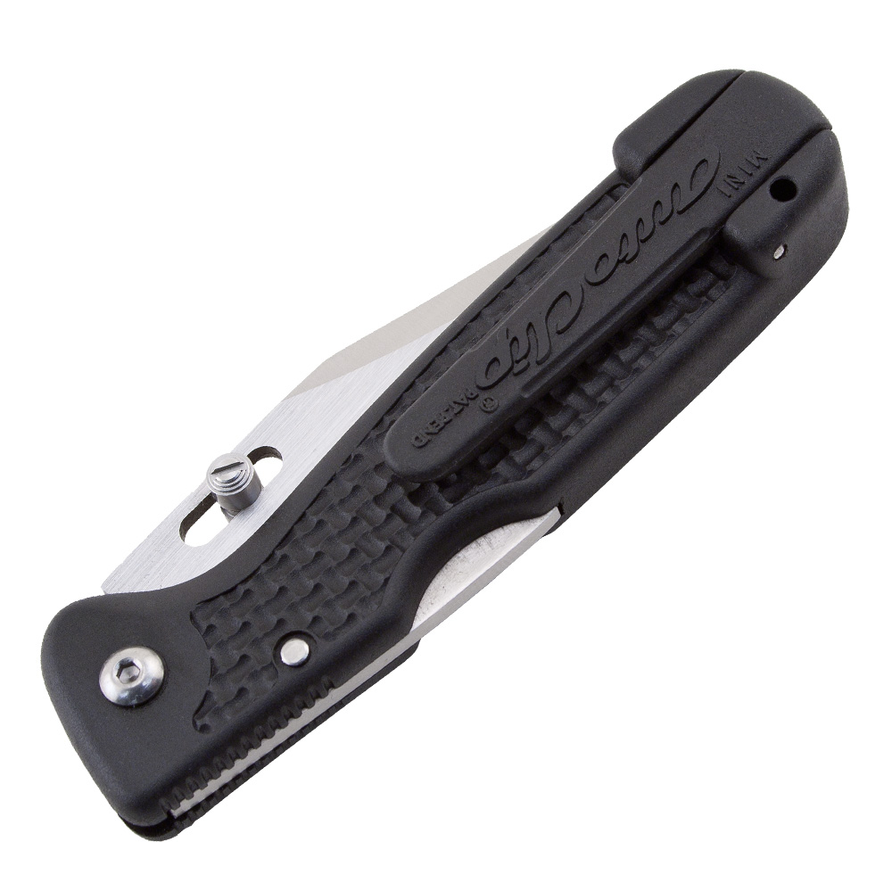
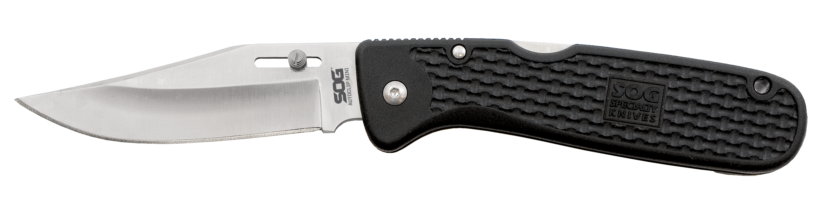
FINISH SATIN POLISHED
BLADE SHAPE CLIP POINT
EDGE TYPE STRAIGHT
BLADE STEEL TYPE 420 STAINLESS
HANDLE MATERIAL GLASS-REINFORCED NYLON (GRN)
HARDNESS RC. 51-53
PRODUCT WEIGHT 1.7 OZ
BLADE LENGTH 2.7”
CLOSED LENGTH 4”
OVERALL LENGTH 6.7”
MODEL NUMBER AC10-CP
UPC 729857994057

