BladeLight Hunt
Adding a healthy dose of light to your favorite hunting knife, the Bladelight embeds six exceptionally bright LED lights into the glass-reinforced nylon handle creating a fixed-blade knife designed to illuminate your ventures afield.

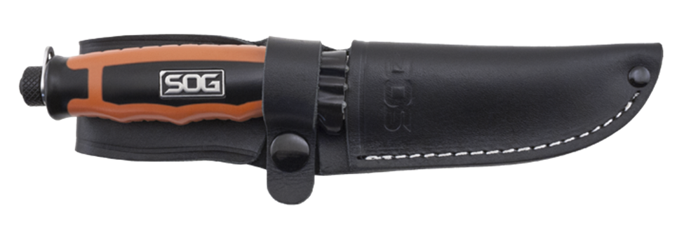
SOG has paid extra attention to the exacting demands and needs of hunters in recent years, and this new member of the award-winning Bladelight family is destined to become a favorite among big game aficionados. The six intensely bright LED lights (three on each side of the blade) have a measured output of 30 lumens that’ll shine a whole new light on field-dressing activities. Its dual-purpose design will be a welcome addition in the woods, finding a blood trail or the way in and out of the stand. The fixed skinning blade – made of 8CR13MOV stainless steel – is anchored to a glass reinforced nylon handle. Two AAA batteries will provide more than four hours of burn time for the LED lights.

Key Selling Features:
- Fixed blade knife with brilliant white LEDs for use in low light situations
- Satin polished 8Cr13MoV 3.8-inch Stainless Steel blade
- Water Resistance: IPX-7 Protected for water immersion. (Immersion time 30 minutes at a depth of 1 meter)
- Glass-reinforced Nylon Handle with Rubber over mold and 6 LEDs built into the handle
- Black Leather sheath
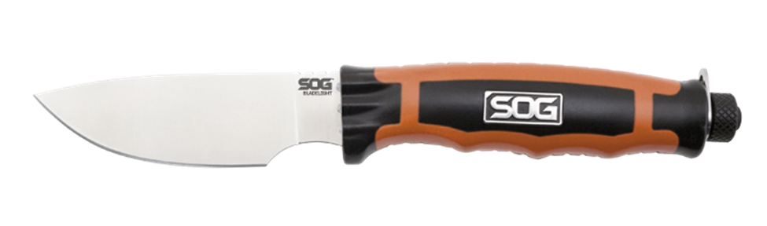
- Overall length: 11.3-inches, Weight: 7.1-ounces, Lifetime Warranty
FINISH SATIN POLISHED
BLADE SHAPE DROP POINT
EDGE TYPE STRAIGHT
BLADE STEEL TYPE 8CR13MOV
HANDLE MATERIAL GLASS REINFORCED NYLON (GRN) / THERMOPLASTIC RUBBER (TPR)
HARDNESS RC. 56-58
PRODUCT WEIGHT 4.3 OZ
BLADE LENGTH 3.8”
OVERALL LENGTH 8.5”
MODEL NUMBER BLT20L-CP
UPC 729857000123

