BladeLight Camp
Designed to make outdoor living simpler and brighter, the BladeLight embeds six exceptionally bright LED lights into the glass-reinforced nylon handle creating a fixed-blade knife that lights up a campsite.

SOG sets its sights on becoming the leader in lighted blades. This new member of the award-winning BladeLight family will find a special place among campers and outdoor enthusiasts. The six intensely bright LED lights (three on each side of the blade) have a measured output of 30 lumens, enough to light up a camping stove or the way to the outhouse during the night. The fixed blade – made of 8CR13MOV stainless steel – is anchored to a glass reinforced nylon handle. Two AAA batteries will provide more than four hours of burn time.

Key Selling Features:
- Fixed blade knife with brilliant white LEDs for use in low light situations
- Satin polished 8Cr13MoV 4.5-inch Stainless Steel blade
- Water Resistance: IPX-7 Protected for water immersion. (Immersion time 30 minutes at a depth of 1 meter)
- Glass-reinforced Nylon Handle with Rubber over mold and 6 LEDs built into the handle
- Black Leather sheath
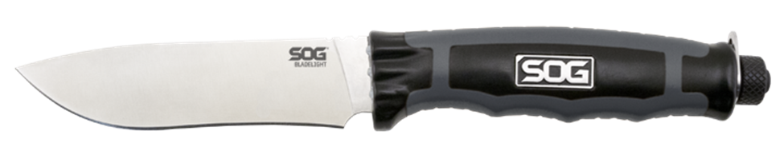
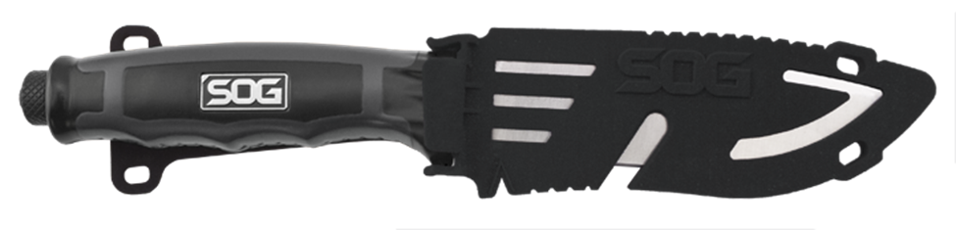
- Overall length: 9.2-inches, Weight: 4.3-ounces, Lifetime Warranty
FINISH SATIN POLISHED
BLADE SHAPE DROP POINT
EDGE TYPE STRAIGHT
BLADE STEEL TYPE 8CR13MOV
HANDLE MATERIAL GLASS REINFORCED NYLON (GRN) / THERMOPLASTIC RUBBER (TPR)
HARDNESS RC. 56-58
PRODUCT WEIGHT 4.3 OZ
BLADE LENGTH 4.5”
OVERALL LENGTH 9.2”
MODEL NUMBER BLT21K-CP
UPC 729857000130

