BladeLight Tactical
Combining the best blade features of a tactical knife with the practicality of a tactical light, the BladeLight Tactical stands ready to serve in any operation. The six red LED lights provide superior visibility for use with night vision optics.

Long a trusted member of tactical operations around the world, SOG readies for deployment in low light situations with this new member of the award-winning BladeLight family. The six intensely bright red LED lights (three on each side of the blade) have a measured output of 37 lumens and are designed for use in conjunction with night optics needed by military or law enforcement specialists. The fixed blade – made of 8CR13MOV stainless steel – is anchored to a glass reinforced black nylon handle. Two AAA batteries will provide more than four hours of burn-time for the LED lights.

Key Selling Features:
- Fixed blade knife with red LEDs in handle for use in low light situations.
- Hardcased Black 8Cr13MoV 4.5-inch Stainless Steel Blade
- Glass-reinforced Nylon Handle with Over-molded Rubber and 6 LEDs built into the handle
- Molded Nylon sheath with belt clip, sharpener, and cord cutter
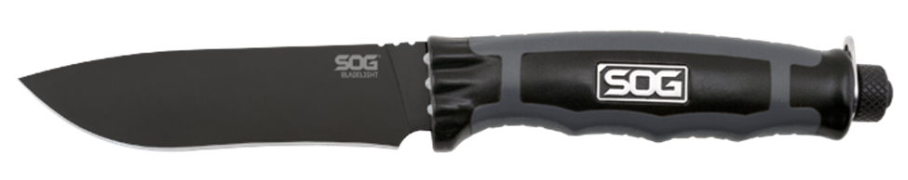
- Overall length: 9.5-inches, Weight: 4.3-ounces, Lifetime Warranty
FINISH HARDCASED BLACK
BLADE SHAPE DROP POINT
EDGE TYPE STRAIGHT
BLADE STEEL TYPE 8CR13MOV
HANDLE MATERIAL GLASS REINFORCED NYLON (GRN) / THERMOPLASTIC RUBBER (TPR)
HARDNESS RC. 56-58
PRODUCT WEIGHT 4.3 OZ
BLADE LENGTH 4.5”
OVERALL LENGTH 9.2”
MODEL NUMBER BLT22K-CP
UPC 729857000154

