BladeLight Fillet (6.0”)
SOG’s first fillet knife adds smartly adds six exceptionally bright LED lights into the glass-reinforced nylon handle creating a fillet knife that makes it easier to see and clean your catch.

SOG’s first fishing specific knife is definitely a keeper. This new member of the award-winning BladeLight family features a 6-inch fillet knife accompanied by six intensely bright LED lights (three on each side of the blade). The lights, with an output of 30 lumens, will make fish cleaning or bait cutting in the dying hours of the day so much easier. It could help find the way to the boat launch or mooring. The fixed blade – made of 8CR13MOV stainless steel – is anchored to a glass reinforced nylon handle. Two AAA batteries will provide more than four hours of burntime for the LED lights. That’s a lot of fish cleaning.

Key Selling Features:
- Fixed blade fillet knife with brilliant white LEDs in handle for use in low light situations.
- Satin polished 8Cr13MoV 6-inch Stainless Steel Fillet Blade
- Glass-reinforced Nylon Handle with Rubber over mold and 6 LEDs built into the handle
- Molded Nylon sheath with belt clip, sharpener, and cord cutter
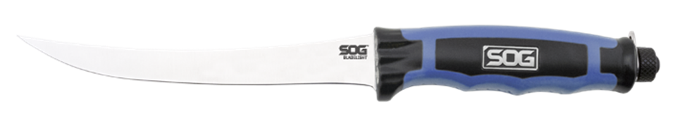
- Overall length: 10.7-inches, Weight: 3.2-ounces, Lifetime Warranty
FINISH SATIN POLISHED
BLADE SHAPE FILLET
EDGE TYPE STRAIGHT
BLADE STEEL TYPE 8CR13MOV
HANDLE MATERIAL GLASS REINFORCED NYLON (GRN) / THERMOPLASTIC RUBBER (TPR)
HARDNESS RC. 56-58
PRODUCT WEIGHT 3.2 OZ
BLADE LENGTH 6.0”
OVERALL LENGTH 10.7”
MODEL NUMBER BLT31K-CP
UPC 729857000192

