Micron 2.0 – Black, Tanto
Designed to go wherever you go, the SOG Micron series can easily be carried on any keychain or lanyard. Crafted from high quality stainless steel, this tiny tool is thinner than most car keys, but strong enough for light duty cutting tasks. Its full stainless steel construction make this a durable and lightweight blade. It’s there when you need it and out of the way when you don’t.

Key Selling Features:
- Easily carried on a keychain or lanyard
- 2.25-inch hardcased black straight edge tanto 420 stainless steel blade
- Full stainless steel construction built to last
- Lockback locking mechanism ensures that it won’t open in your pocket or close when in use
- Overall length: 5.0-inches, Weight: 1.4-ounces, Lifetime Warranty
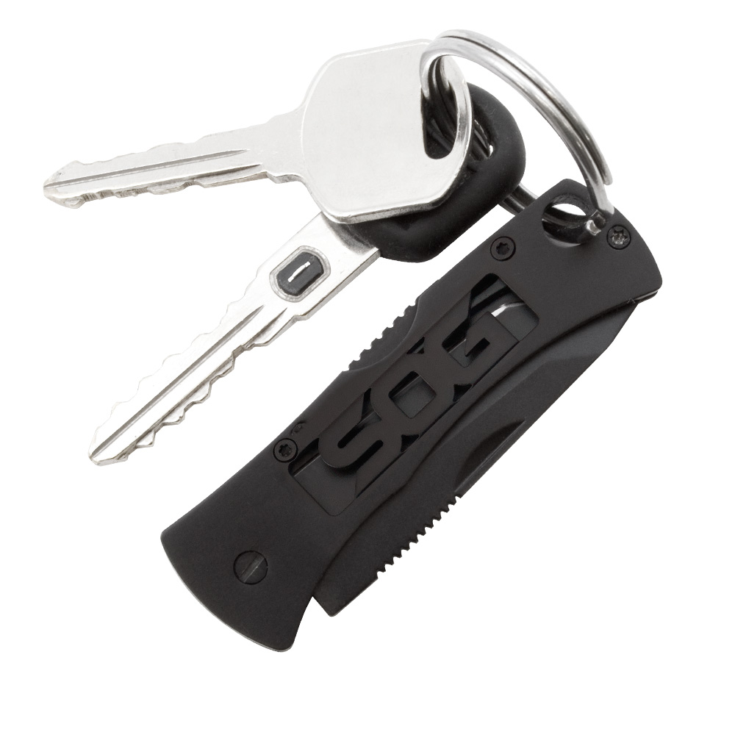
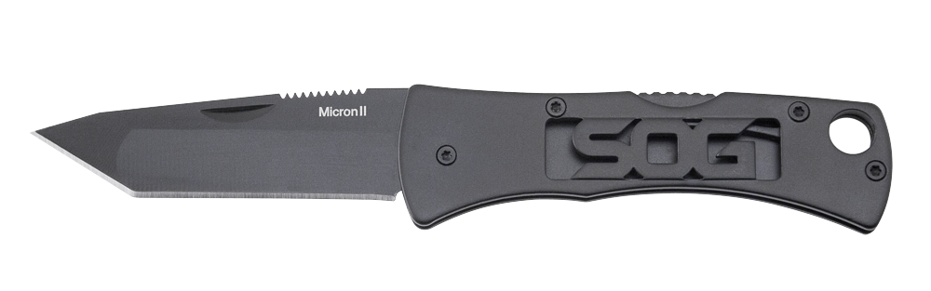
FINISH HARDCASED BLACK
BLADE SHAPE TANTO
EDGE TYPE STRAIGHT
BLADE STEEL TYPE 420 STAINLESS STEEL
HANDLE MATERIAL STAINLESS STEEL
HARDNESS RC. 51-53
PRODUCT WEIGHT 1.4 OZ
BLADE LENGTH 2.25”
CLOSED LENGTH 2.75”
OVERALL LENGTH 5.0”
MODEL NUMBER FF91-CP
UPC 729857994347

