ParaTool
The ParaTool is the only multi-tool with a multiple angled plier head capable of fitting into awkward spots. The unique and patented way the ParaTool opens allows for the ability to operate at a variety of angles (140˚-180˚) which is indispensable in tight spots. The comfort grip handles are smooth on the outside and feature SOG’s classic ventilation holes for maximum gripping. Be prepared with the ParaTool.

Key Selling Features:
- Exclusive folding plier head works at several angles without losing gripping power
- Stainless steel handles and plier head with satin polished finish
- Total Components: 14
- Nylon carry pouch
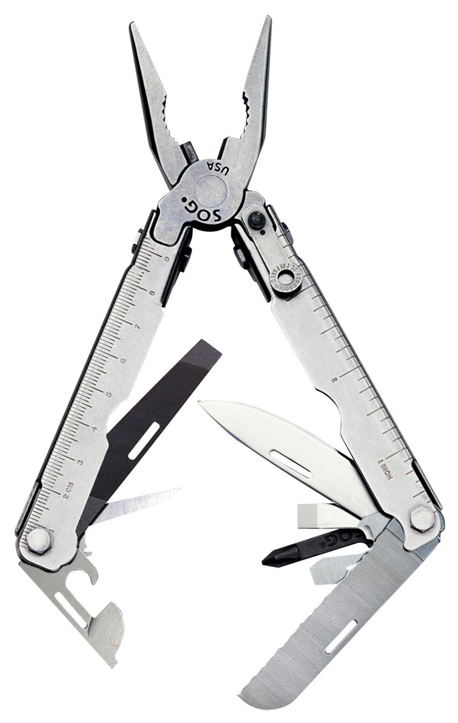
- Open: 6.4-inches, Closed: 4.3-inches, Weight: 6.2-ounces, Lifetime Warranty
FINISH SATIN POLISHED
STEEL TYPE 420 STAINLESS
HANDLE MATERIAL 420 STAINLESS
TOOLS MULTI-ANGLE NEEDLE NOSE PLIERS
3-SIDED FILE
AWL
BOLT GRIP CHANNEL
BOTTLE OPENER
CAN OPENER
FULL SERRATED BLADE
SLOTTED SCREWDRIVERS (S/M/L)
PHILLIPS SCREWDRIVER
RULER
STRAIGHT EDGE BLADE
PRODUCT WEIGHT 6.2 OZ
CLOSED LENGTH 4.3”
OVERALL LENGTH 6.4”
MODEL NUMBER S31-N
UPC 729857000314

