Flashback – Satin, Tanto

This recent addition to the SOG family offers outdoor enthusiasts a utility knife that is up for any challenge. Built with a strong GRN frame reinforced with a stainless steel shell and ribbed finger grips, the Flashback is solid to hold and easy to use. The GRN benefits from high strength to weight ratio and impact resistance. The sharp-looking knife is equipped with SOG’s latest assisted opening technology that gives it the distinction of being one of the fastest assisted opening blades available. Like many other SOG folders, the Flashback features a strong piston lock system, double thumb studs for ambidextrous one-handed opening, and reversible low-carry pocket clip which make it great for EDC.

Key Selling Features:
- Opens faster and with more purpose than any other assisted knife available
- 3.5-inch straight edge AUS-8 steel tanto shape blade with a satin polished finish
- Black and silver handle is made of glass-reinforced nylon and stainless steel that fits comfortably in your hand
- Includes a low-carry reversible pocket clip
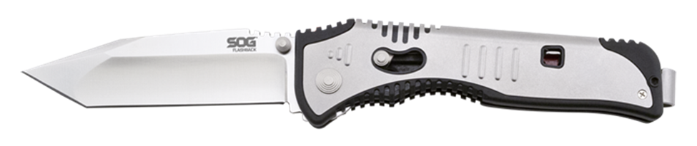
- Overall length: 8.0-inches, Weight: 3.7 ounces, Lifetime Warranty
FINISH SATIN POLISHED
BLADE SHAPE TANTO
EDGE TYPE STRAIGHT
BLADE STEEL TYPE AUS-8
HANDLE MATERIAL ZYTEL / STAINLESS STEEL
HARDNESS RC. 57-58
PRODUCT WEIGHT 3.7 OZ
BLADE LENGTH 3.5”
CLOSED LENGTH 4.5”
OVERALL LENGTH 8.0”
MODEL NUMBER SAT003-CP
UPC 729857998833

