Access Card 2.0
The Access Card 2.0 doesn't grant entry into top secret facilities, but it does give a sense of security. The minimalistic design of the Access Card 2.0 does not take up much space. Measured as just 3/16” think without the clip, it can be carried anywhere. The 2.75" formidable VG-10 blade opens and closes with one hand like a magic trick and locks with our famously strong Arc-Lock. The high quality VG-10 blade ensures that every cut is as sharp as the first. Although every bit of excess weight has been engineered out of the Access Card 2.0, you will be surprised at the power it conveys.

Key Selling Features:
- Easy one-handed opening and ambidextrous Arc-Lock
- 2.75-inch hardcased black TiNi straight edge VG-10 blade
- Stainless steel handle
- Removable low-carry pocket/money clip
- Overall length: 6.2-inches, Weight: 1.8-ounces, Lifetime Warranty

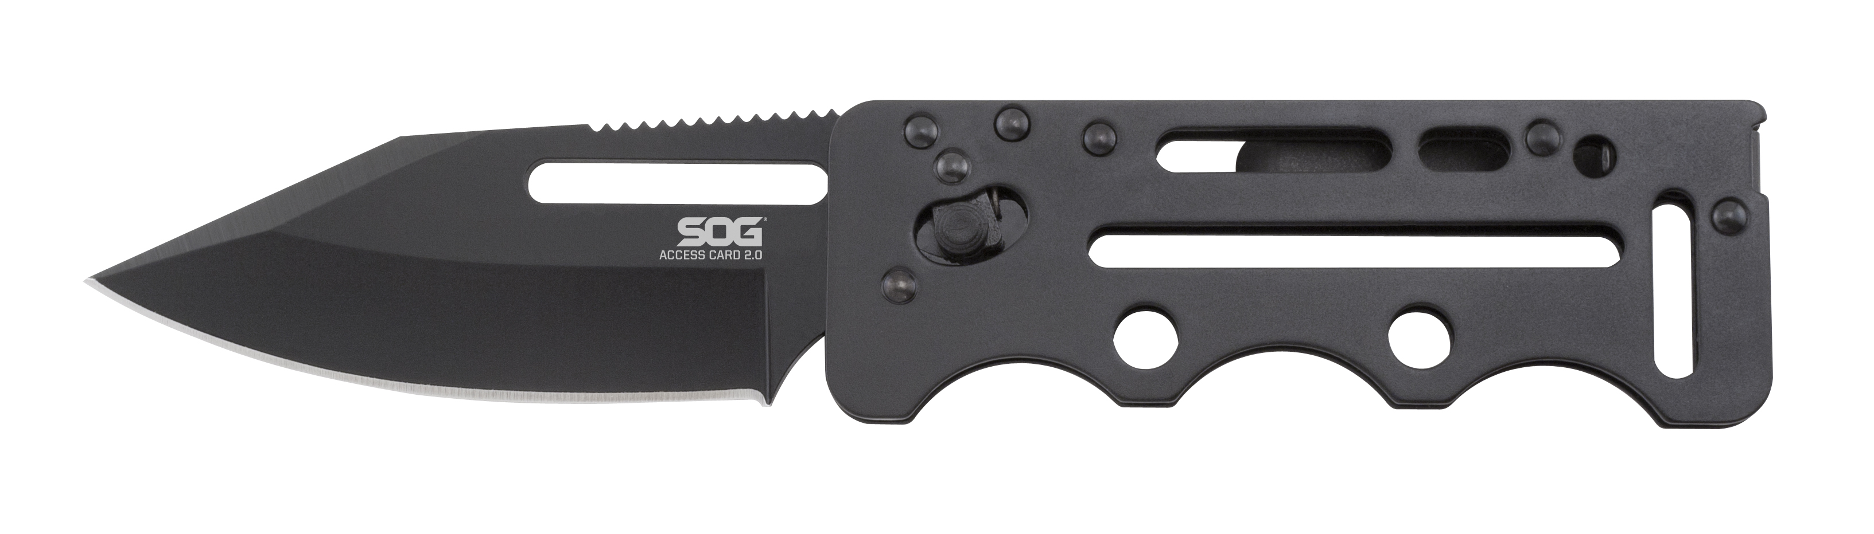
FINISH HARDCASED BLACK TINI
BLADE SHAPE CLIP POINT
EDGE TYPE STRAIGHT
BLADE STEEL TYPE VG-10
HANDLE MATERIAL STAINLESS STEEL
HARDNESS RC. 59-60
PRODUCT WEIGHT 1.8 OZ
BLADE LENGTH 2.75”
CLOSED LENGTH 3.45”
OVERALL LENGTH 6.2”
MODEL NUMBER SOGAC77
UPC 729857991957

