SOGzilla Large – Black, Straight
Resembling the claw of a prehistoric animal, the SOGzilla series is built with stout construction to handle any cutting task. The durable glass-reinforced nylon (GRN) is textured to give increased user control and grip. The thumb hole allows opening with either hand. In hand, the knife points instinctually and feels familiar. The steel liners make a stout and durable construction. The lockback mechanism keeps the blade locked when in use. It comes equipped with a reversible low-carry pocket clip and a lanyard hole.

Key Selling Features:
- Large folding pocket knife
- 3.82-inch straight edge 8Cr13MoV stainless steel blade
- Textured glass-reinforced nylon handle with stainless steel liners
- Reversible low-carry pocket clip
- Overall length: 8.54-inches, Weight: 4.8 ounces, Lifetime Warranty

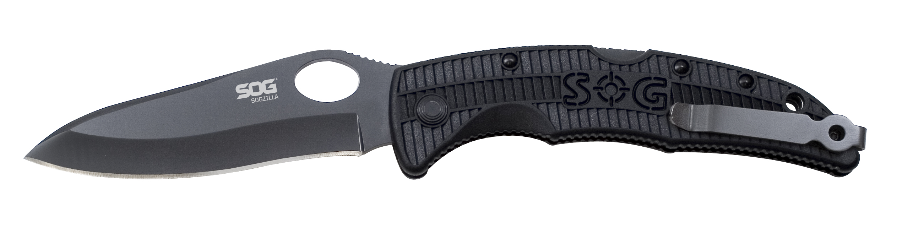
FINISH HARDCASED BLACK
BLADE SHAPE DROP POINT
EDGE TYPE STRAIGHT
BLADE STEEL TYPE 8CR13MOV
HANDLE MATERIAL GLASS-REINFORCED NYLON (GRN)
HARDNESS RC. 56-58
PRODUCT WEIGHT 4.8 OZ
BLADE LENGTH 3.8”
CLOSED LENGTH 4.75”
OVERALL LENGTH 8.54”
MODEL NUMBER SP23-CP
UPC 729857994446

