Demo
The Demo is the most rare of the Special Forces SOG knives in existence. In fact, only one original is known to exist today. Originally, 39 were made and 38 of these were delivered to the Naval Advisory Detachment for missions on the North Vietnamese coastline. They were issued to OPLAN 34 ALPHA in 1964 at which time 36 were lost in operations and two were never seen again. Using current manufacturing techniques, we are now able to create a spectacular reproduction of this ultra rare knife, with a modern twist.

Key Selling Features:
- Modern version of classic knife originally designed in Vietnam War era
- 7.2-inch straight and partially serrated edge black TiNi coated AUS-8 stainless steel blade
- Kraton rubber handle with stainless steel crossguard
- Includes Leather Sheath w/ belt loop
- Overall length: 11.8-inches, Weight: 12.3 ounces, Lifetime Warranty
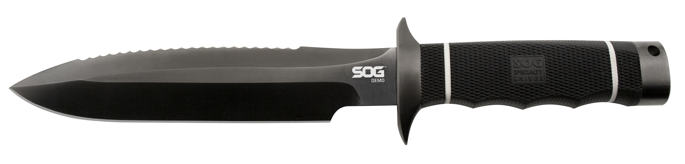
FINISH HARDCASED BLACK TINI
BLADE SHAPE SPEAR POINT
EDGE TYPE STRAIGHT / SERRATED
BLADE STEEL TYPE AUS-8
HANDLE MATERIAL KRATON
HARDNESS RC. 57-58
PRODUCT WEIGHT 12.2 OZ
BLADE LENGTH 7.25”
OVERALL LENGTH 11.75”
MODEL NUMBER SSD01-L
UPC 729857995825

