Tsunami
With the reintroduction of this popular SOG knife, we have taken what made the Tsunami so great and improved it. Some of the changes are subtle - like refining the overall balance. Some are more obvious, like the grooves in our crossguards and the option of a tough TiNi coating. Finally, the beautiful Tsunami blade shape is mated perfectly with an extremely tactile diamond checkered Kraton handle. Explore this next generation of a great classic.

Key Selling Features:
- Medium-sized tanto fixed blade
- 6.5-inch straight edge AUS-8 stainless steel blade
- Kraton rubber handle with stainless steel crossguard
- Includes MOLLE-compatible ballistic nylon sheath
- Overall length: 10.9-inches, Weight: 6.8 ounces, Lifetime Warranty
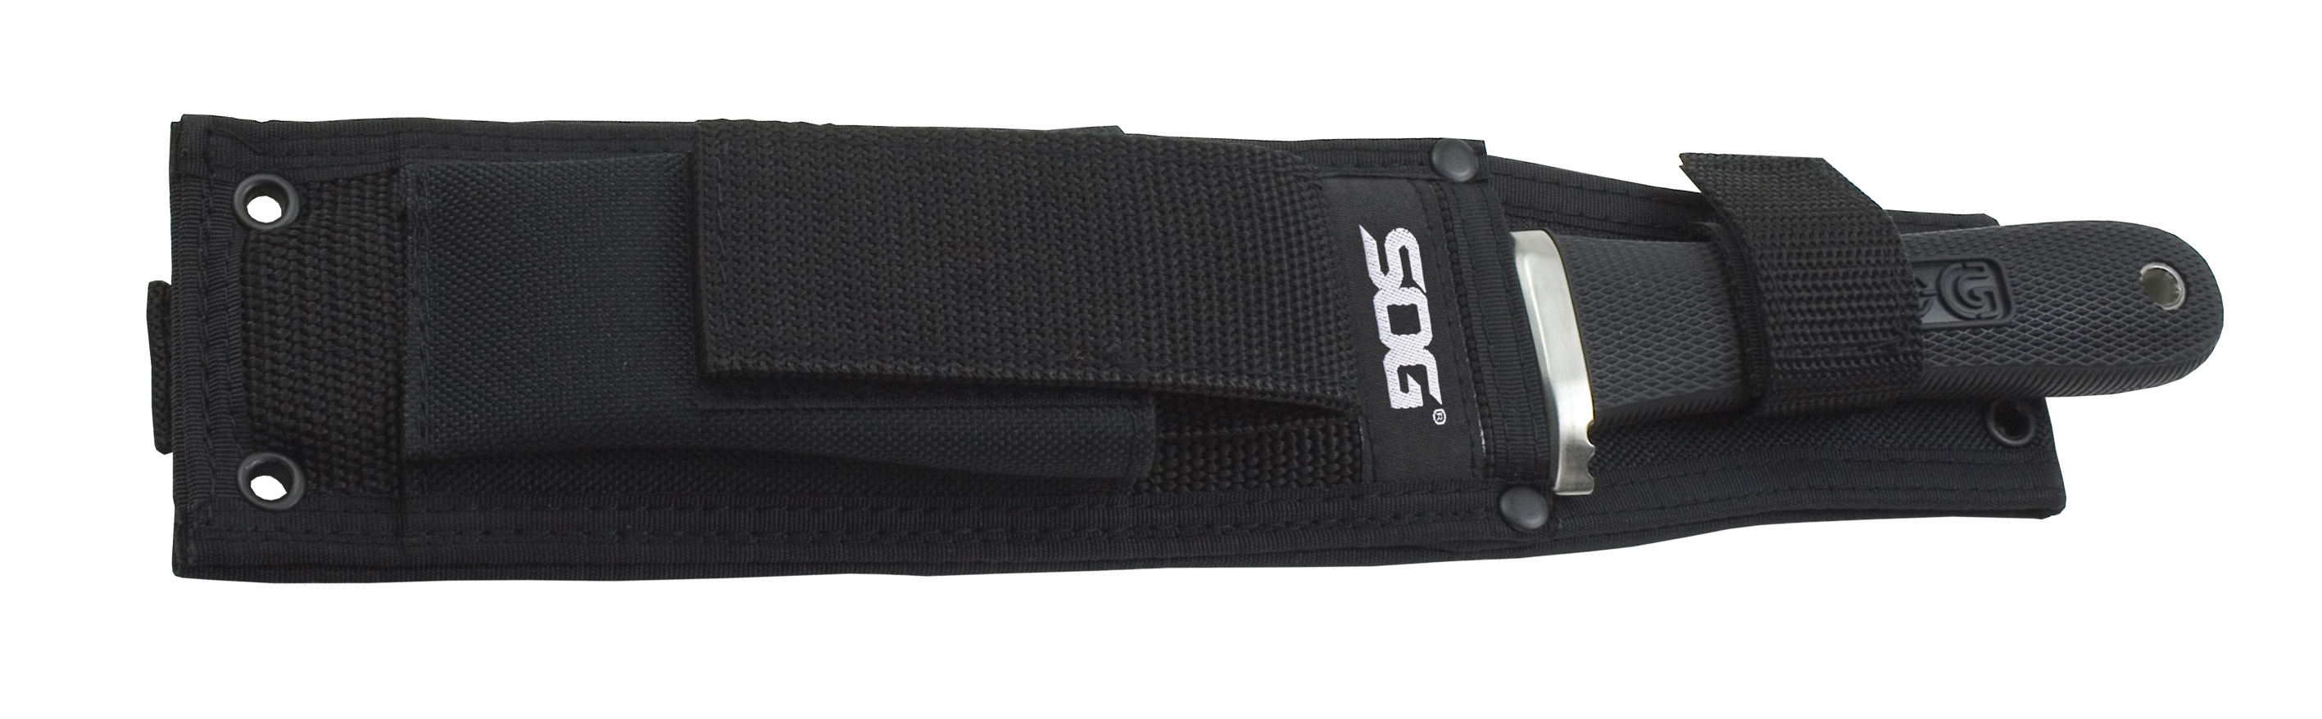
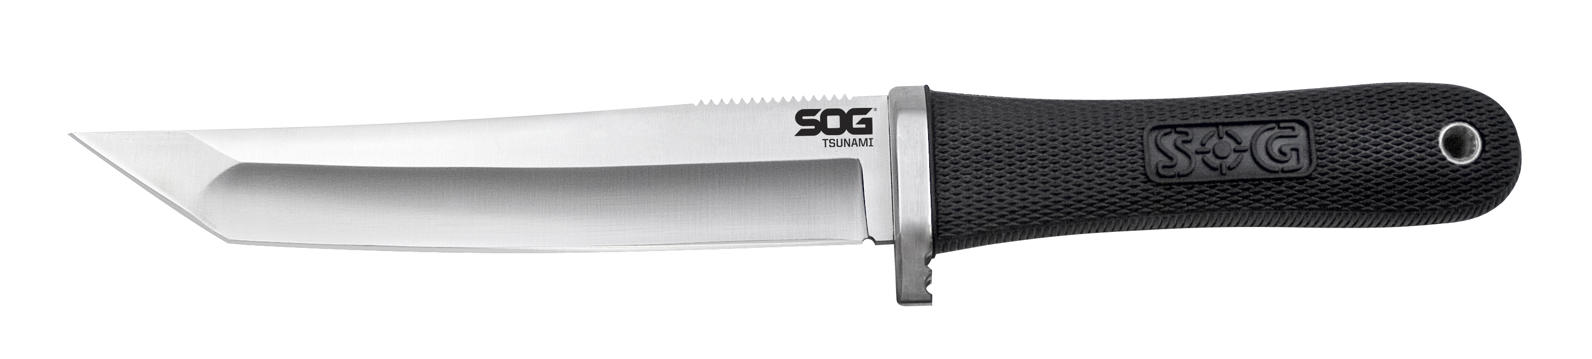
FINISH SATIN POLISHED
BLADE SHAPE TANTO
EDGE TYPE STRAIGHT
BLADE STEEL TYPE AUS-8
HANDLE MATERIAL KRATON RUBBER
HARDNESS RC. 57-58
PRODUCT WEIGHT 6.8 OZ
BLADE LENGTH 6.5”
OVERALL LENGTH 10.9”
MODEL NUMBER TS01-N
UPC 729857992756

