Arcitech – Jigged Bone
The Arcitech ushered in our Platinum line with an exquisite high-end collectable. Combining technical excellence with a spirited new design, the Arcitech has that trait that is so elusive; harmony. A mirror polished san mai (VG-10 core laminated with 420J2 stainless steel) exotic blade moves smooth as silk and mechanically effortless thanks to our very special Arc-Lock. The titanium bolsters meet old school jigged bone in a rare and beautiful combination. Produced in very limited quantities only, the Arcitech is an Investment collectable.

The Arc-Lock just might be the perfect lock. Why? It is totally ambidextrous and has all of the attributes knife designers relentlessly search for, but rarely find. Strength: The Arc-Lock far surpasses conventional lock strength, tested at over 1000 lbs of force measured at the lock in an independent lab test. Speed: The Arc-Lock provides lightning-quick, one-handed opening and closing capability. Safety: Spring-action securely retains the blade closed. When unlocking, the fingers are safely kept clear. Durability: The Arc-Lock is self-adjusting over time and can be easily cleaned for long-term optimal performance.

Key Selling Features:
- Easy one-hand opening and ambidextrous Arc-Lock
- Mirror polished San Mai VG-10 3.5-inch blade with Abalone thumb stud
- Jigged bone handle with Titanium bolster and liners
- Reversible low carry pocket clip
- Overall length: 8-inches, Weight: 4.5 ounces, Lifetime Warranty
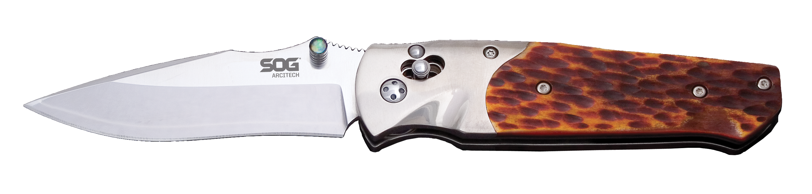
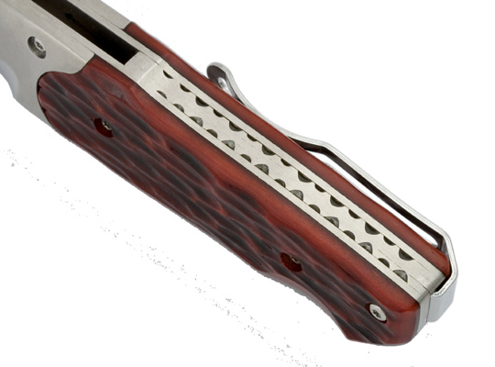
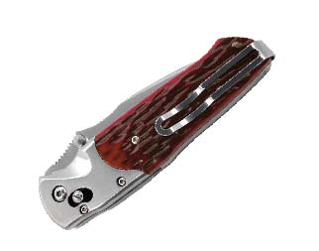
FINISH MIRROR POLISHED
BLADE SHAPE CLIP POINT
EDGE TYPE STRAIGHT
BLADE STEEL TYPE SAN MAI VG-10
HANDLE MATERIAL TITANIUM / JIGGED BONE
HARDNESS RC. 59-60
PRODUCT WEIGHT 4.5 OZ
BLADE LENGTH 3.5”
CLOSED LENGTH 4.5”
OVERALL LENGTH 8”
MODEL NUMBER A01-P
UPC 729857990608

