Arcitech – Damascus
To create, a truly unique experience and first for SOG we started with one of our finest knives, the Arcitech. Then we procured a stunning Japanese Damascus that uses a core of VG-10 and 15 layers of Nickel and stainless steel on either side. The steel is forged and folded again and again to produce this striking pattern. Then finally the knife is acid etched to bring the pattern up clearly (carbon and nickel become black).
The Arc-Lock just might be the perfect lock. Why? It is totally ambidextrous and has all of the attributes knife designers relentlessly search for, but rarely find. Strength: The Arc-Lock far surpasses conventional lock strength, tested at over 1000 lbs of force measured at the lock in an independent lab test. Speed: The Arc-Lock provides lightning-quick, one-handed opening and closing capability. Safety: Spring-action securely retains the blade closed. When unlocking, the fingers are safely kept clear. Durability: The Arc-Lock is self-adjusting over time and can be easily cleaned for long-term optimal performance.

Key Selling Features:
- Easy one-hand opening and ambidextrous Arc-Lock
- Hand crafted Damascus 3.5-inch blade with Abalone thumb stud
- Textured Carbon Fiber handle with Titanium bolster and liners
- Reversible low carry pocket clip
- Overall length: 8-inches, Weight: 4.5 ounces, Lifetime Warranty
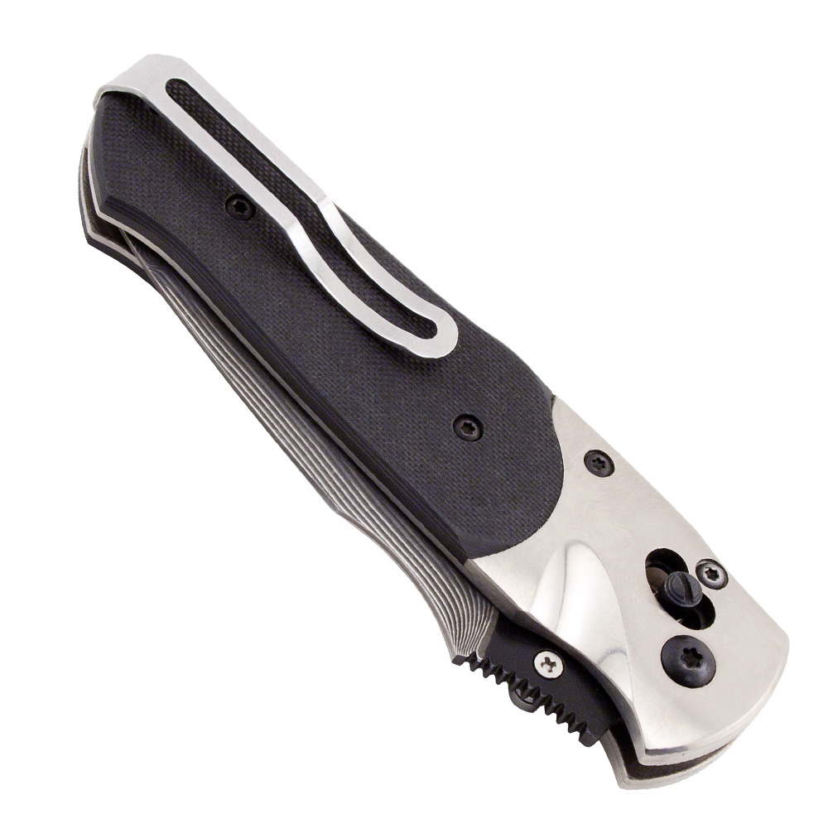
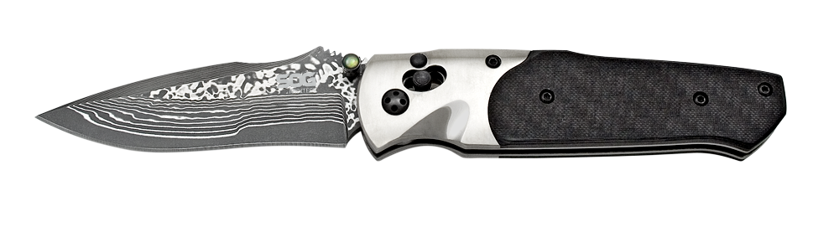
FINISH DAMASCUS
BLADE SHAPE CLIP POINT
EDGE TYPE STRAIGHT
BLADE STEEL TYPE DAMASCUS (VG-10 / NICKEL)
HANDLE MATERIAL TITANIUM / CARBON FIBER
HARDNESS RC. 59-60
PRODUCT WEIGHT 4.5 OZ
BLADE LENGTH 3.5”
CLOSED LENGTH 4.5”
OVERALL LENGTH 8”
MODEL NUMBER A03-P
UPC 729857993036

