Aegis – Black Tini, Tanto, ½ Serrated, Digi Camo
Aegis (ee-jis), which in Greek means shield or protection, is also the code name for the world's premier integrated air defense system and the sea-based element of the United States Ballistic Missile Defense System. Our comprehensive Aegis line of premier folders is fully integrated with top end systems. Start to open the knife and let Aegis finish the action with a bang, using one of the surest assisted technologies (S.A.T.) out there! Our trademark bayonet reversible clip, built in safety with green and safely locked, checkered DigiGrip handle to make Aegis a platform for today's changing world. Cover your back with Aegis outdoor or tactical blades.
Our comprehensive Aegis line of premier folders is fully integrated with top end systems. Take the new modified arc actuated piston locks that enable and supports several blade configurations. Start to open the knife, and let Aegis finish the action with a bang, using one of the surest assisted technologies (S.A.T.) out there! Our trademark bayonet reversible clip, built in safety with red/ready to go, checkered DigiGrip™ handles, and tacky rubber inserts all contribute to make Aegis a platform for today’s changing world. Cover your back with Aegis outdoor or tactical blades

Key Selling Features:
- Fast one-hand opening SOG Assisted Technology (SAT) with built in blade safety lock
- 3.5-inch black TiNi coated ½ serrated AUS8 stainless steel tanto blade
- Rugged Digi Camo Glass-reinforced Nylon handle with rubber inserts
- Low carry reversible bayonet pocket clip
- Overall length: 8.25-inches, Weight: 3.1 ounces, Lifetime Warranty
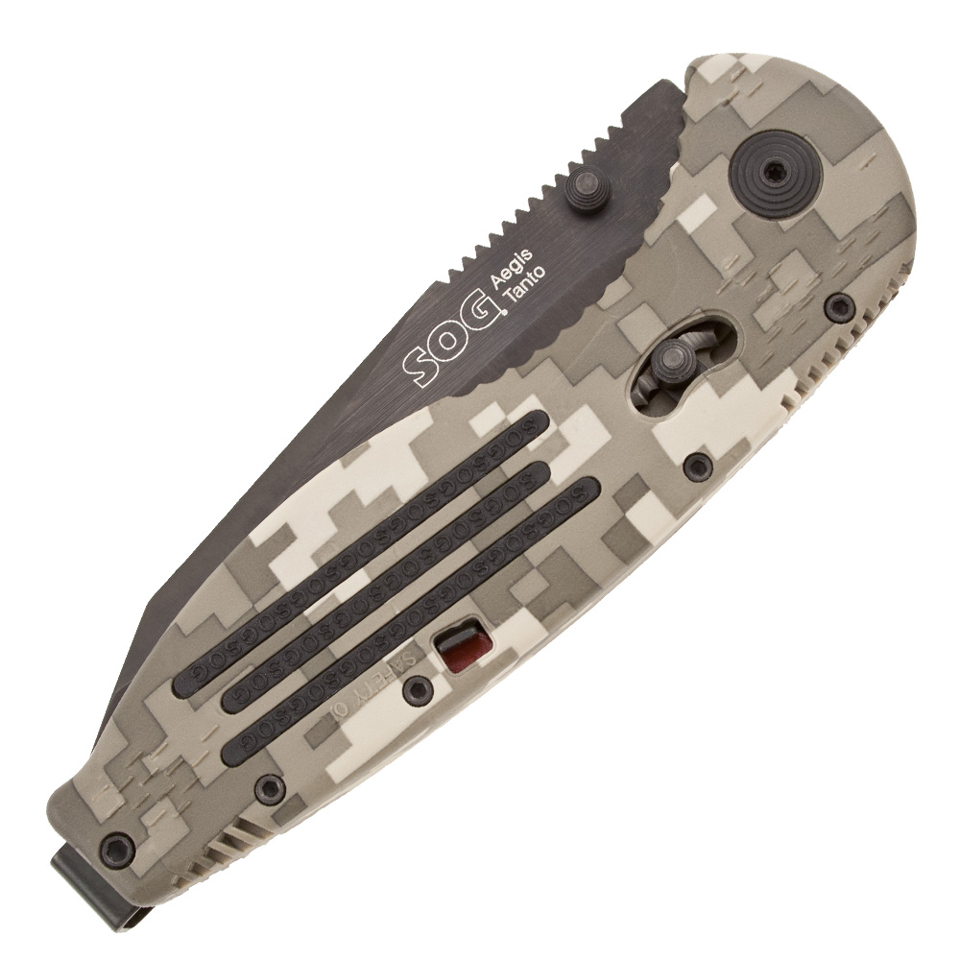
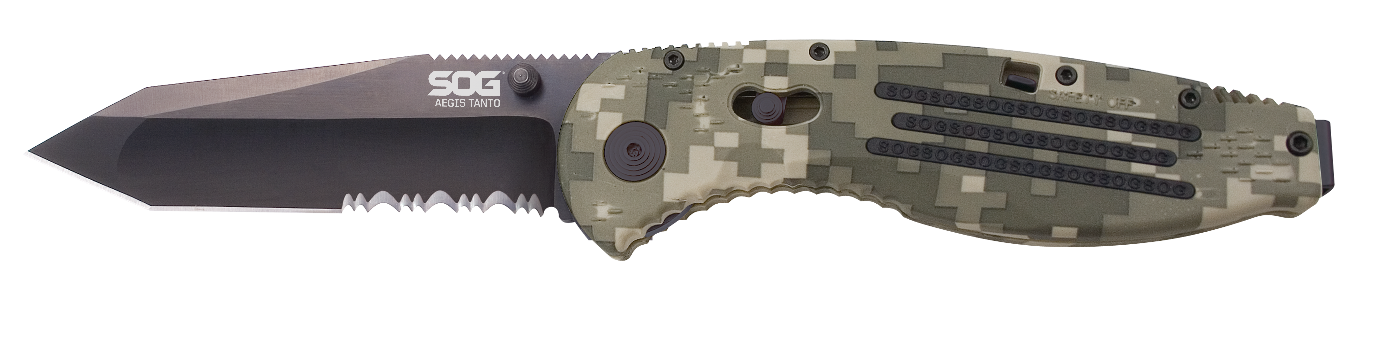
FINISH HARDCASED BLACK TINI
BLADE SHAPE TANTO
EDGE TYPE PARTIALLY SERRATED
BLADE STEEL TYPE AUS-8
HANDLE MATERIAL GLASS-REINFORCED NYLON (GRN)
HARDNESS RC. 57-58
PRODUCT WEIGHT 3.1 OZ
BLADE LENGTH 3.5”
CLOSED LENGTH 4.75”
OVERALL LENGTH 8.25”
MODEL NUMBER AE07-CP
UPC 729857994118

