PowerLock EOD 2.0 – V-Cutter, Black
Using the proven PowerLock chassis, SOG is the only company to apply Compound Leverage™ technology to EOD (Explosive Ordnance Disposal). This makes it a breeze to crimp blasting caps and demolition cord using less hand pressure. Another unique SOG feature is the positioning of the crimper device within the confines of the handle instead of the plier jaw like other designs. This serves to minimize collateral damage to the crimper and allows the operator to have full use of the uninterrupted plier surface. Additionally there is no weakening of the pliers that often causes breakage of the plier tips. The crimper produces non-flaring, high pullout strength crimps that meet government fuse well specifications. It is also GSA approved. Includes the V-Cutter, used to cut seat belts, paracord, fishing line, electrical cable sheathing, and much more.

Key Selling Features:
- SOG’s Compound Leverage design generates twice the gripping power than regular pliers
- Stainless steel handles and plier head with non-reflective black oxide coating
- 15 tool components
- Includes leather (B63-L) or nylon (B63N-CP) carry pouch
- Open: 7.0-inches, Closed: 4.6-inches, Weight: 9.6-ounces, Lifetime Warranty
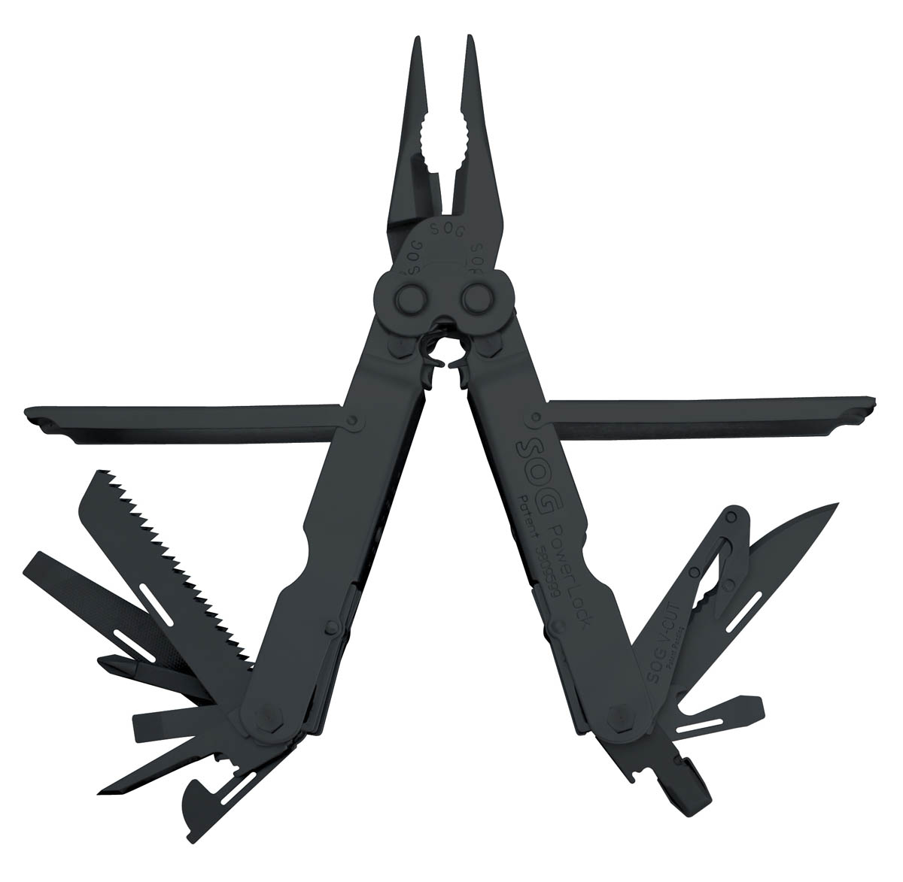
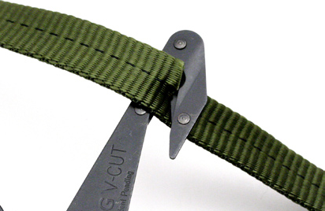
FINISH BLACK OXIDE
STEEL TYPE 420 STAINLESS
HANDLE MATERIAL 420 STAINLESS
TOOLS NEEDLE NOSE PLIERS / GRIPPER
HARD WIRE CUTTER
¼” DRIVE
WIRE CRIMPER
BLASTING CAP CRIMPER
2 ¾” ½ SERRATED DROP POINT BLADE
WOOD SAW
3-SIDED FILE
BOLT GRIP CHANNEL
SLOTTED SCREWDRIVERS (S/M/L)
PHILLIPS SCREWDRIVER
AWL
CAN OPENER
BOTTLE OPENER
SCISSORS
V-CUTTER
RULERS
PRODUCT WEIGHT 9.6 OZ
CLOSED LENGTH 4.6”
OVERALL LENGTH 7.0”
MODEL NUMBER B63-L / B693N-CP
UPC 729857992381 / 729857993982

