PowerLock EOD 2.0 – Fuzewell Spike
Welcome to the next generation of our best-selling PowerLock! Like the original, the newest generation includes patented gear driven Compound Leverage™, one-handed flip opening, and a multitude of easy to access tools. New to this generation are several key features. First, a larger plier head with larger cutting surface offers more area to grip and cut. Then, then gear covers adds comfort and safety in addition to a streamlined look. Lastly, the tool includes v-cutter and a EOD exclusive: a C-4 spike which is useful as a marlin spike, tool scribe, and glass breaker. Comes in matte black finish for low reflectivity.

Key Selling Features:
- SOG’s Compound Leverage design generates twice the gripping power than regular pliers
- Stainless steel handles and plier head with non-reflective black oxide coating
- 15 tool components
- Nylon carry pouch
- Open: 7.0-inches, Closed: 4.6-inches, Weight: 9.6-ounces, Lifetime Warranty

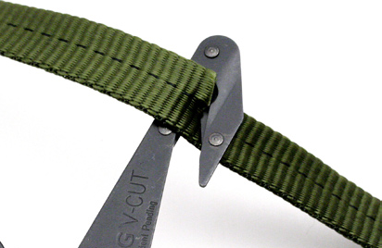
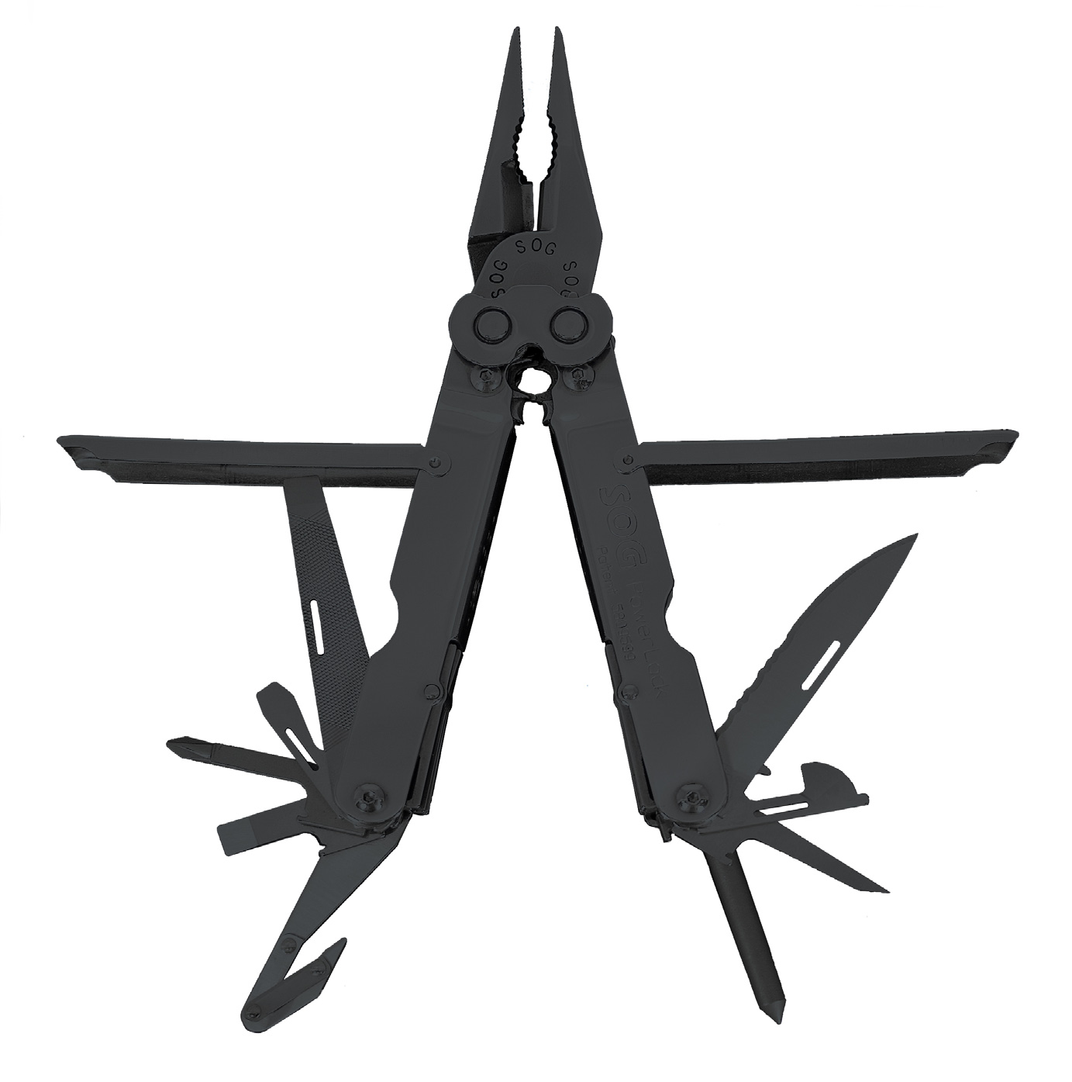
FINISH BLACK OXIDE
STEEL TYPE 420 STAINLESS
HANDLE MATERIAL 420 STAINLESS
TOOLS NEEDLE NOSE PLIERS / GRIPPER
HARD WIRE CUTTER
WIRE CRIMPER
BLASTING CAP CRIMPER
2 ¾” ½ SERRATED DROP POINT BLADE
3-SIDED FILE
BOLT GRIP CHANNEL
SLOTTED SCREWDRIVERS (S/M/L)
PHILLIPS SCREWDRIVER
AWL
CAN OPENER
BOTTLE OPENER
V-CUTTER
C-4 / FUZEWELL SPIKE
RULERS
LANYARD RING
PRODUCT WEIGHT 9.6 OZ
CLOSED LENGTH 4.6”
OVERALL LENGTH 7.0”
MODEL NUMBER B69N-CP
UPC 729857994033

