CrossCut 2.0
The CrossCut 2.0 is precision instrument for cutting, personal care, and the unexpected. SOG’s gear driven Compound Leverage gives you cutting power of a much bigger tool in a small package. The CrossCut is easy to open and use. The small form factor make this tool easy to take with you wherever you go.

Key Selling Features:
- Exclusive patented Compound Leverage generates twice the cutting power
- Satin polished stainless steel handles and scissor head
- Fits on keying for easy carry
- Total Components: 9
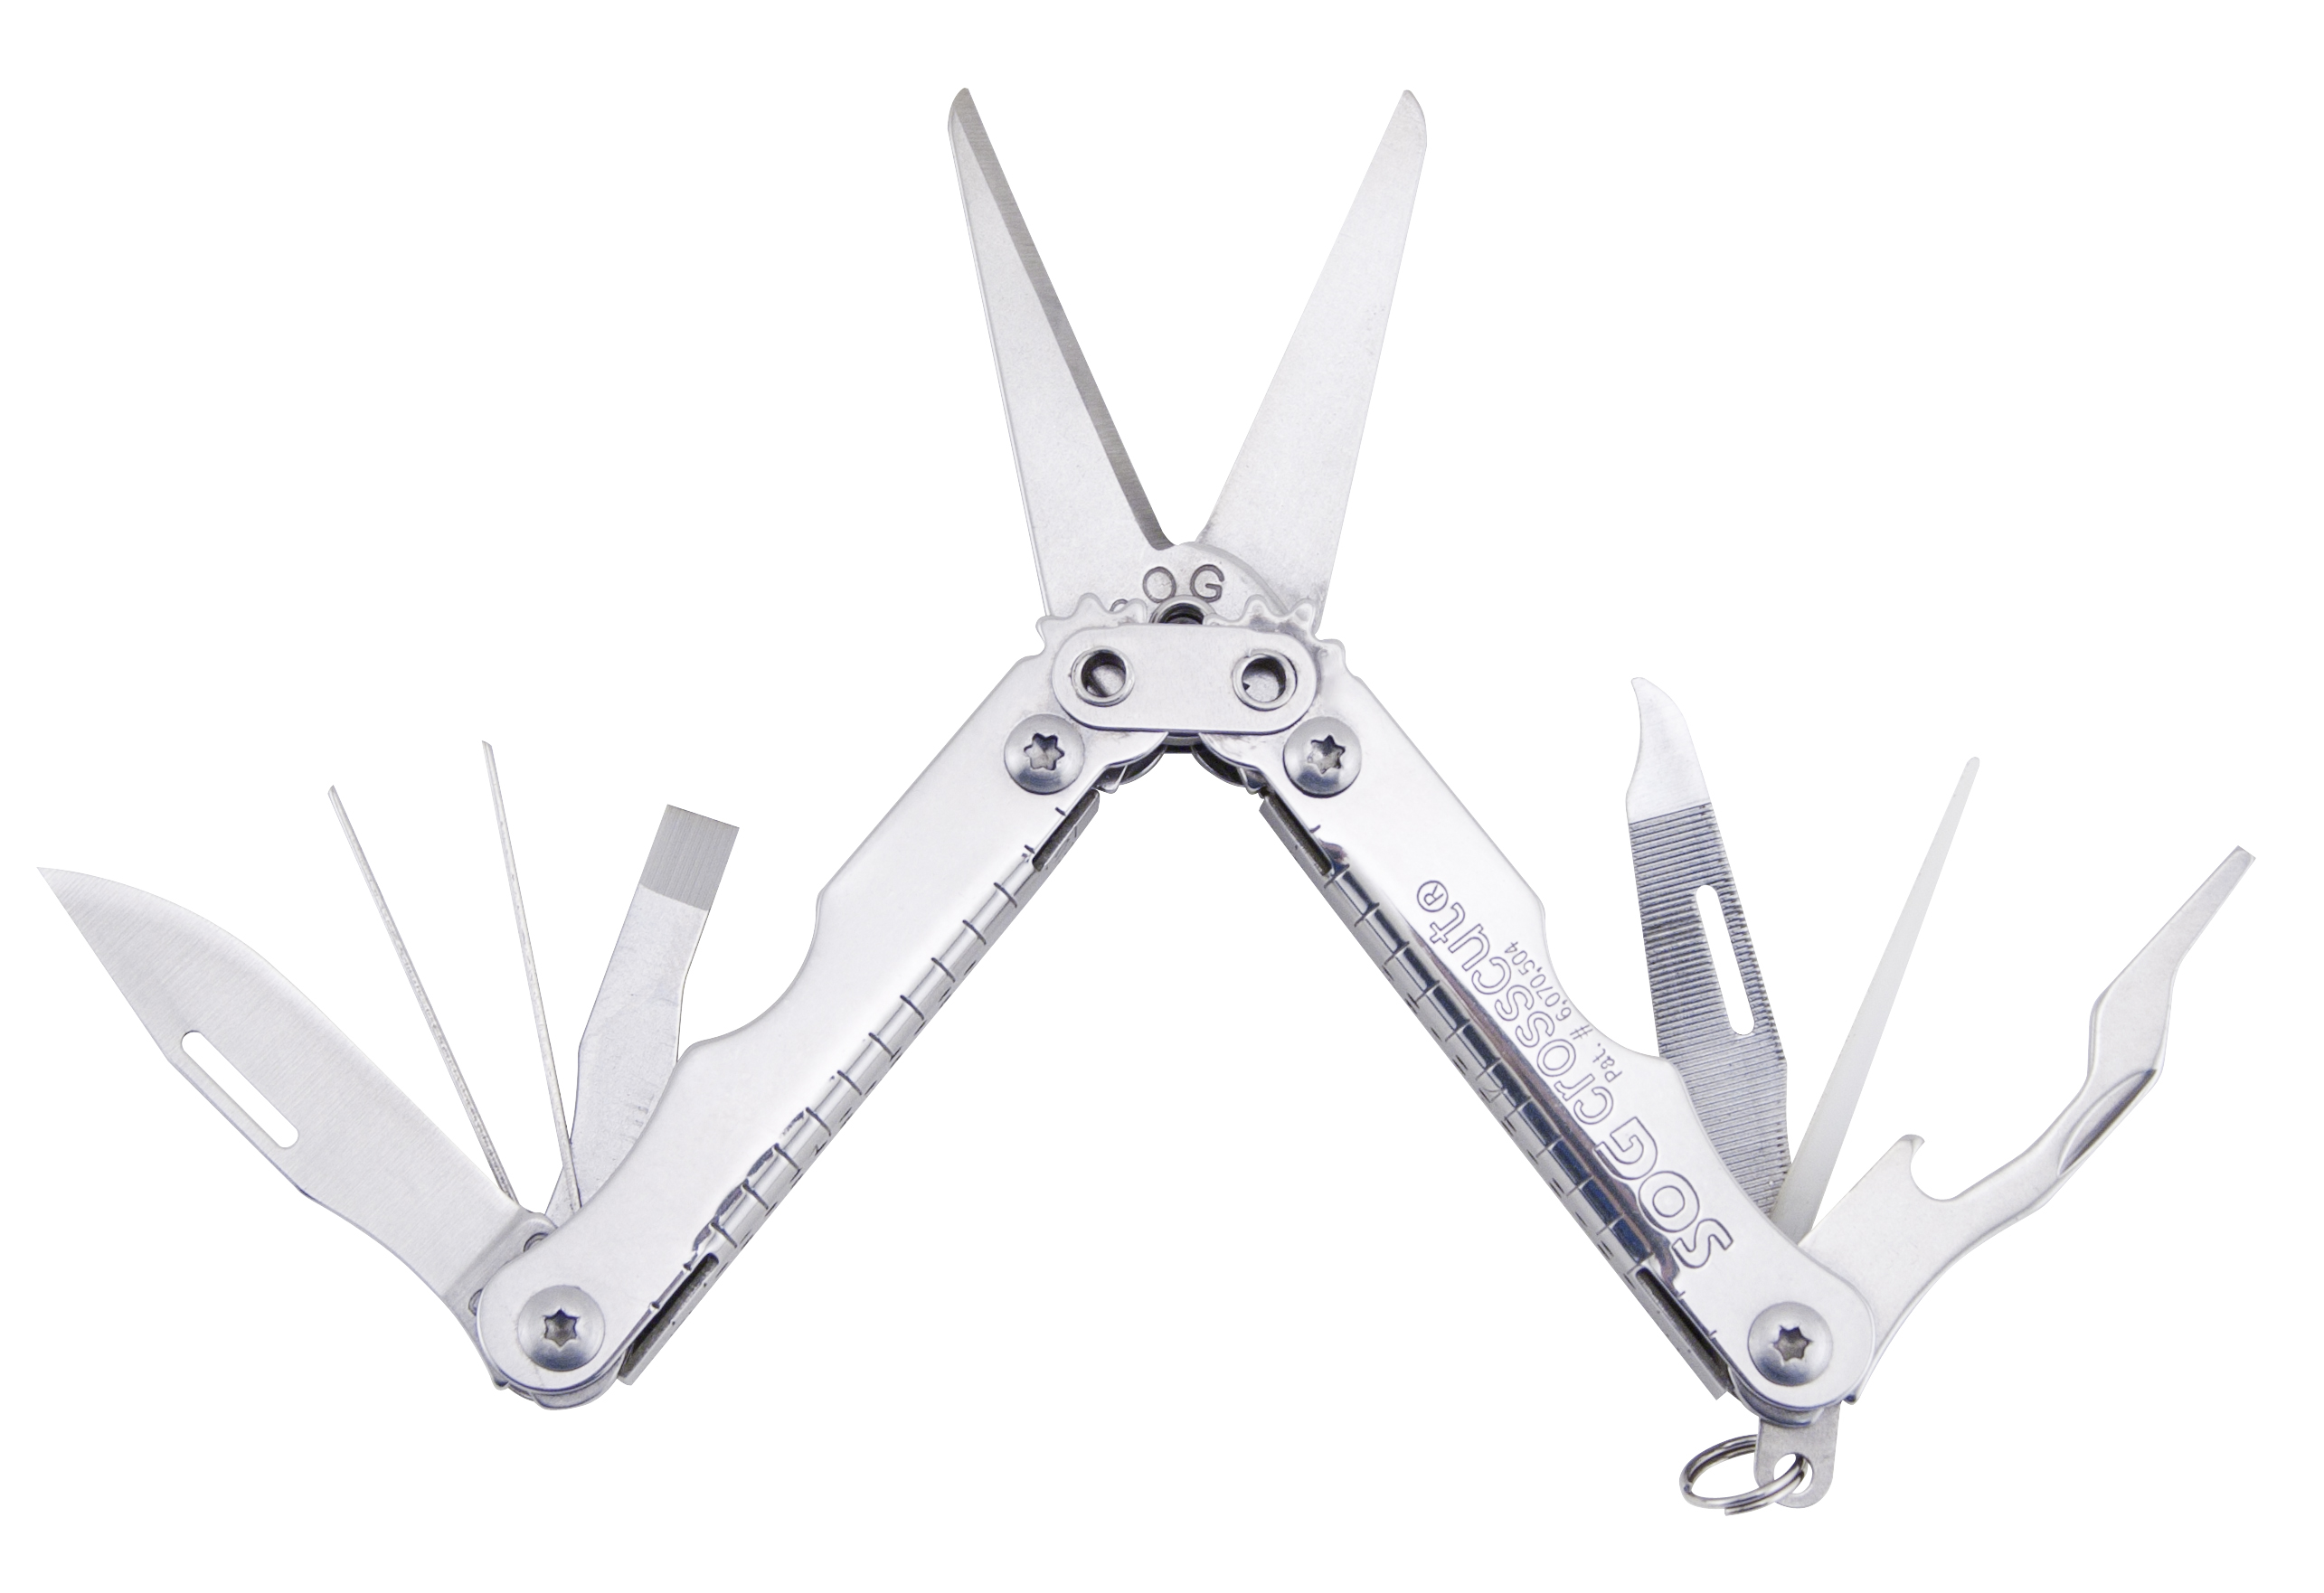
- Open length: 4-inches, Closed length: 2.5-inches, Weight: 1.7-ounces, Lifetime Warranty"
FINISH SATIN POLISHED
STEEL TYPE 420 STAINLESS
HANDLE MATERIAL 420 STAINLESS
TOOLS SCISSORS
SLOTTED SCREWDRIVERS (S/M)
NAIL FILE
BOTTLE OPENER
STRAIGHT EDGE BLADE
TOOTHPICK
TWEEZERS
RULER
LANYARD/KEYCHAIN RING
PRODUCT WEIGHT 1.7 OZ
CLOSED LENGTH 2.5”
OVERALL LENGTH 4.0”
MODEL NUMBER CC51-CP
UPC 729857994927

