Creed - Satin
With one of the more dramatic blade shapes in the SOG arsenal, the Creed is a definite head-turner. It is not only attractive, it also delivers on its promise of high-level performance. The very stout front end weighs the knife forward for chopping and piercing. The big belly on the blade maximizes the cutting edge for wilderness and hunting situations. The Tech Bowie handle provides a confident grip in inclement weather. This is a great example of a collectable and working knife coming together.

Key Selling Features:
- Tough Kraton handle borrowed from the famous SOG Tech Bowie
- 7.5-inch straight edge satin finished AUS8 stainless steel blade
- Slip-resistant and comfortable Kraton rubber handle w/ stainless steel crossguard and pommel
- Black leather sheath
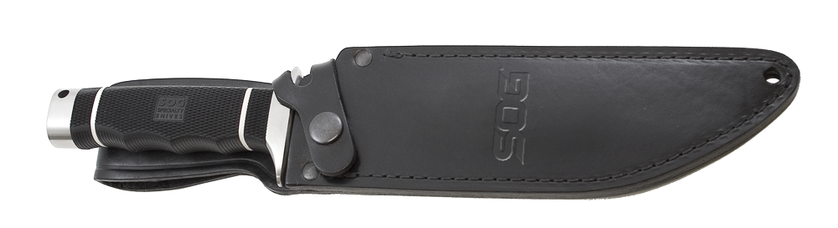
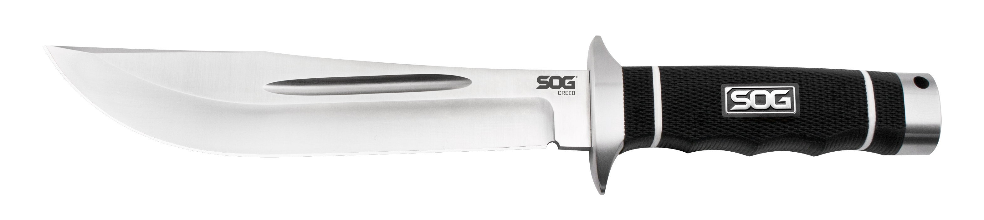
- Overall length: 12.125-inches, Weight: 12.8-ounces, Lifetime Warranty
FINISH SATIN POLISHED
BLADE SHAPE CLIP POINT
EDGE TYPE STRAIGHT
BLADE STEEL TYPE AUS-8
HANDLE MATERIAL KRATON RUBBER
HARDNESS RC. 57-58
PRODUCT WEIGHT 12.8 OZ
BLADE LENGTH 7.5”
OVERALL LENGTH 12.125”
MODEL NUMBER CD01-L
UPC 729857992107

