Dark Energy 750A
SOG's line of flashlights, Dark Energy, pierces the night with ease. They look different and they behave differently. Our goal was simple. We wanted you to have the brightest flashlights of their size. You will be surprised at the power and durability of these lights as soon as you hold one.

Packing 687 lumens in the palm of your hand, you can light up the tree tops and down trails. The SOG Dark Energy 750A has the power and range for many tasks. We wanted to be able to utilize different power settings quickly, so we developed a single-button switch that allows users to go through 5 modes: momentary on/off, 100% power, 40% power, reading, and tactical strobe without the need to press and hold the button. The 6061 T6 aluminum housings are aggressively checkered - more than any other - and are coated in a Class III anodizing for maximum durability and grip. Count on us when light is not enough, but when blindingly bright is.

Key Selling Features:
- Features a cool white Cree R5 LED bulb with an optical grade polycarbonate lens and textured aluminum reflector
- Maximum output of 687 lumens and a run time of 98 minutes on 100% brightness or 97.73 hours on reading mode
- Five operation modes - Momentary on/off, Full on (100% brightness), Low (40% brightness), Reading (25 lumens), and Strobe
- Water Resistance: IPX-7 Protected against water immersion. (Immersion time 30 minutes at a depth of 1 meter)
- Includes (1) 18650 rechargeable battery and removable belt clip
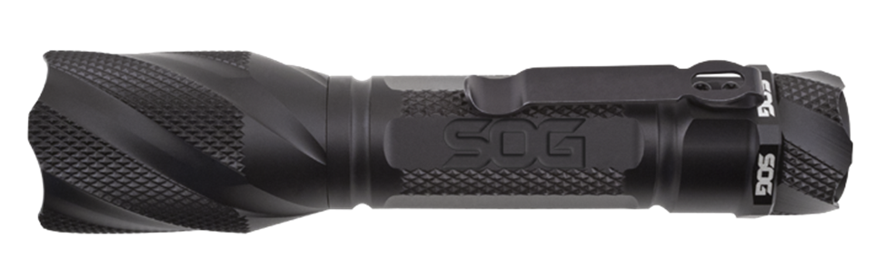
- Overall length: 6.0-inches, Weight: 6.6-ounces, Lifetime Warranty
FINISH ANODIZED ALUMINUM
HANDLE MATERIAL 6061-T6 ALUMINUM
BRIGHTNESS 687 LUMENS (MAX)
BATTERY (1) 18650 RECHARGEABLE
BURN TIME 98 MIN @ 100%
97.73 HRS @ READING MODE
PRODUCT WEIGHT 6.6 OZ
OVERALL LENGTH 6.0”
MODEL NUMBER DE-06
UPC 729857001076

