Tactical Tomahawk – Satin
Based on the Vietnam Tomahawk, the SOG Tactical Tomahawk is an extreme evolution of the original, which was considered one of the more unusual weapons of its day. Today, there is a real need for a versatile tool for breaching operations, excavation, obstacle removal, extraction, and other utility applications. The 420 stainless steel head is mounted to the glass-reinforced nylon handle with heavy-duty bolts and a steel ferrule for additional handle reinforcement. Carried in a nylon sheath this is a universal tool for modern man.

Key Selling Features:
- Versatile tool for breaching, excavation, and other utility applications.
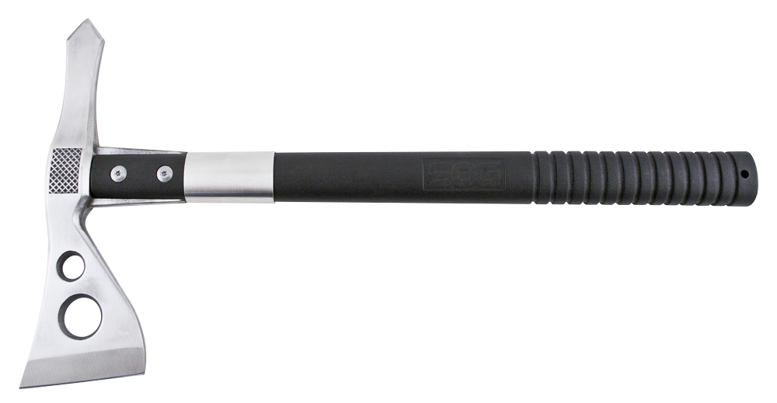
- 2.75-inch stainless steel axe head.
- Balanced weight ratio perfect for throwing.
- Glass-reinforced nylon handle.
- Included nylon sheath w/ belt clip.
- Overall length: 15.75-inches, Weight: 24.0-ounces, Lifetime Warranty
FINISH SATIN POLISHED
BLADE SHAPE AXE
EDGE TYPE STRAIGHT
BLADE STEEL TYPE 420 STAINLESS
HANDLE MATERIAL GLASS REINFORCED NYLON (GRN)
HARDNESS RC. 51-53
PRODUCT WEIGHT 24.0 OZ
BLADE LENGTH 2.75”
OVERALL LENGTH 15.75”
MODEL NUMBER F01PN-CP
UPC 729857997089

