Battle Axe
Our modern battle/throwing axe evokes its origins from medieval times, which some might consider to be the present. Whether used as a target axe, SWAT tool, universal back up, or hung above the fireplace; it is very effective. The pike in the back is upswept for better target penetration. Size and heft are balanced for optimum swing control. The handle is sculpted from heavy duty black G10 and the entire solid blade is protected with hardcased black coating. Nylon sheath included.

Key Selling Features:
- Versatile tool for breaching, excavation, and other utility applications.
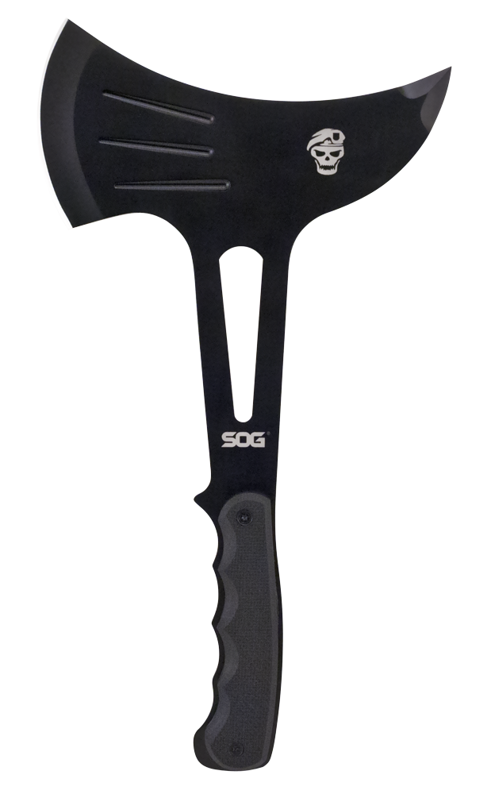
- 3.75-inch stainless steel axe head with pick.
- G10 handle.
- Included nylon sheath w/ belt loop.
- Overall length: 12.25-inches, Weight: 20.2-ounces, Lifetime Warranty
FINISH HARDCASED BLACK
BLADE SHAPE AXE
EDGE TYPE STRAIGHT
BLADE STEEL TYPE 420 STAINLESS
HANDLE MATERIAL G10
HARDNESS RC. 51-53
PRODUCT WEIGHT 20.2 OZ
BLADE LENGTH 3.75”
OVERALL LENGTH 12.25”
MODEL NUMBER F02T-N
UPC 729857990707

