FastHawk – Satin
The SOG FastHawk is faster, lighter, more agile, and easier to carry than its sibling, the Tactical Tomahawk. While it is still powerful, versatile, and functional, it is a tool that will be used for much more than you anticipate. Chopping, breaking, cutting, hammering, piercing, digging, prying, pounding shaving, notching, opening, and throwing are all capabilities well within the FastHawk’s capabilities.

The 420 stainless steel head with a satin polish is mounted to a ballistic polymer handle with heavy-duty bolts and a steel ferrule to insure a solid feed and strong structure. Side hammer checkering insures precision placement when swinging. When carried in the included nylon sheath that can be mounted to belt, backpack, or other gear. It is a universal tool for modern man.

Key Selling Features:
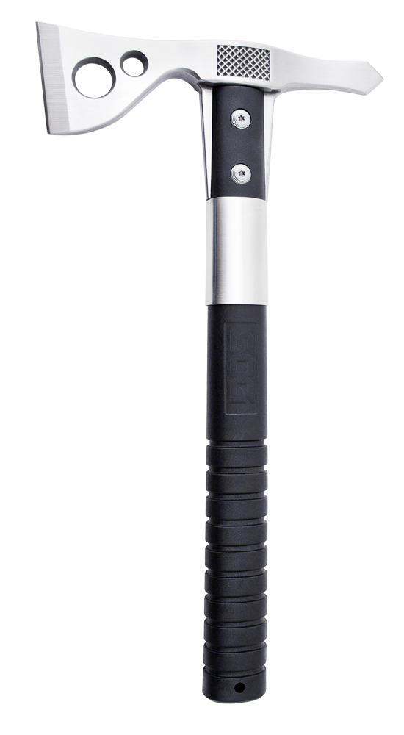
- Lightweight, compact tool for chopping, hammering, and breaching.
- 2-inch stainless steel axe head with satin polish.
- Balanced weight ratio perfect for throwing.
- Glass-reinforced nylon handle.
- Included nylon sheath w/ belt clip.
- Overall length: 12.5-inches, Weight: 19.0-ounces, Lifetime Warranty
FINISH SATIN POLISHED
BLADE SHAPE AXE
EDGE TYPE STRAIGHT
BLADE STEEL TYPE 420 STAINLESS
HANDLE MATERIAL GLASS REINFORCED NYLON (GRN)
HARDNESS RC. 51-53
PRODUCT WEIGHT 19.0 OZ
BLADE LENGTH 2.0”
OVERALL LENGTH 12.5”
MODEL NUMBER F06P-CP
UPC 729857997096

