Entrenching Tool
A folding shovel can be an indispensable tool in today’s constantly changing environment. When you need to move sand, dirt, or snow, a shovel is the best hand tools to have. Our all steel constructed entrenching tool uses a tempered steel blade with teeth cut into one side for cutting and slashing. The blade can be rotated 90 degrees to reveal a pick or to be used as a hoe with the shovel blade. Rotate the blade a full 180 degrees to use the pointed end of the pick in a straight manner. The triangular handle is strong and fits comfortably in either hand. When folded, it takes up about the same space as a stack of paper plates. Before any adventure, make sure you pack this portable, lightweight, and versatile tool.

Key Selling Features:
- Lightweight and compact folding shovel and pick
- Tri-fold design for portability
- Comfortable, folding steel handle
- Includes nylon carrying case w/ gear loops
- Overall length: 18.25-inches, Weight: 24.5 ounces, Lifetime Warranty

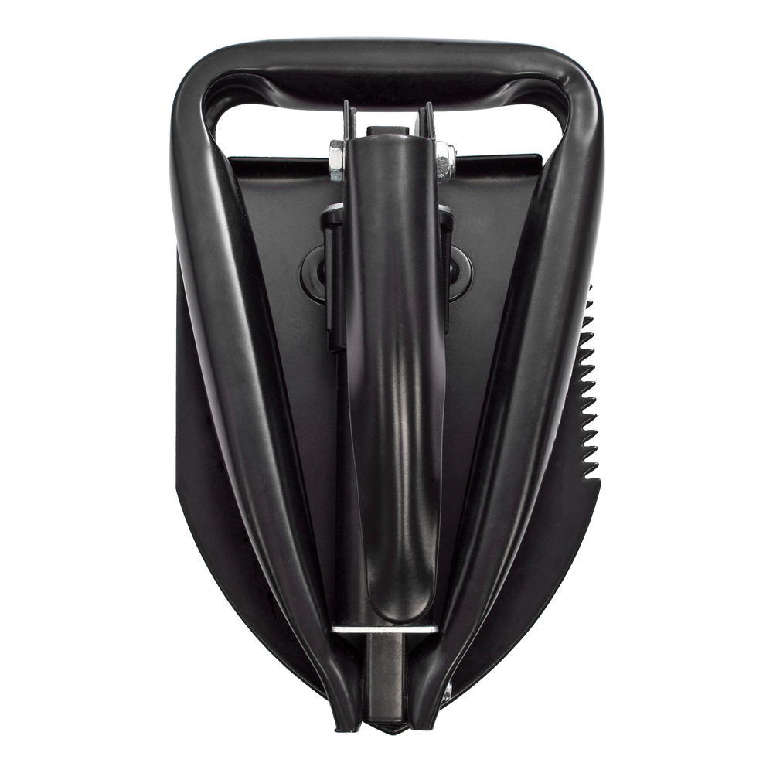
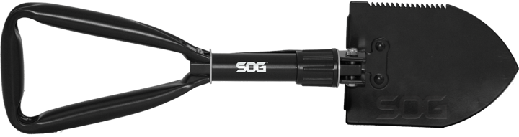
FINISH HARDCASED BLACK
BLADE SHAPE SHOVEL / PICK
EDGE TYPE PARTIALLY SERRATED / STRAIGHT
BLADE STEEL TYPE HIGH CARBON STEEL
HANDLE MATERIAL HIGH CARBON STEEL
PRODUCT WEIGHT 24.5 OZ
CLOSED LENGTH 7.25”
OVERALL LENGTH 24.5”
MODEL NUMBER F08-N
UPC 729857993296

