Hand Axe
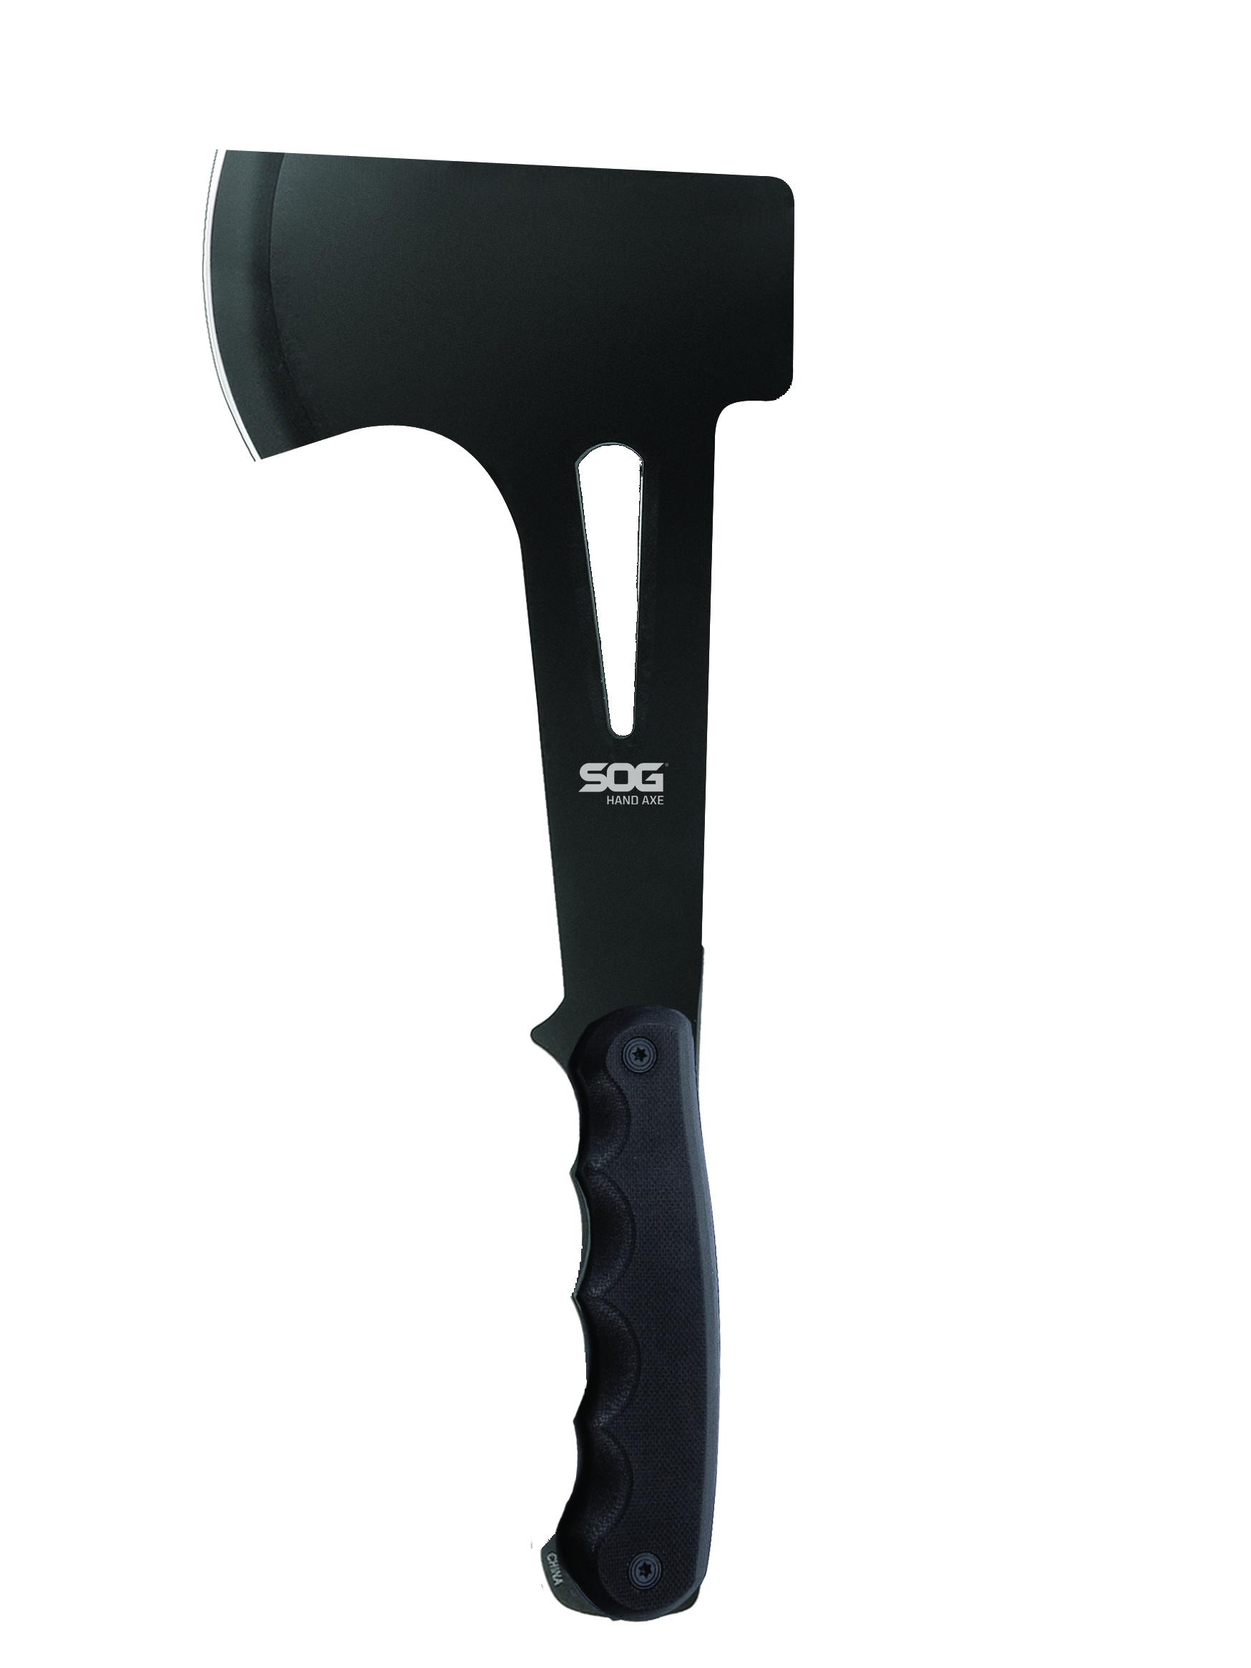
A simple and genuine utilitarian design, the SOG Hand Axe will perform as a wilderness back pack essential as well as a camp, truck and preparedness tool. We opted to include G10 scales on the handles for a more aggressive grip. With enough weight to make short order of camp chores, the SOG Hand Axe also will not punish you when carrying on extended adventure trip.

Key Selling Features:
- Versatile tool for any outdoor task
- 2.4-inch stainless steel axe head
- G10 handle
- Included nylon sheath w/ belt loop
- Overall length: 11.1-inches, Weight: 18.6-ounces, Lifetime Warranty
FINISH HARDCASED BLACK
BLADE SHAPE AXE
EDGE TYPE STRAIGHT
BLADE STEEL TYPE 420 STAINLESS
HANDLE MATERIAL G10
HARDNESS RC. 51-53
PRODUCT WEIGHT 18.6 OZ
BLADE LENGTH 2.4”
OVERALL LENGTH 11.1”
MODEL NUMBER F09N-CP
UPC 729857995115

