Folding Saw
A saw is an essential piece of survival equipment. The longer the saw, the easier to use, but harder to carry. The SOG Folding Saw achieves a nice balance between the two. It has a 8.25” blade of hardened and tempered steel in a hardcased black coating that makes quick work of branches, small logs, and brush. A comfortable handle helps to cut deep and true on each and every pull stroke. The extremely sharp teeth are differentially tempered for long life and work on green as well as hard wood.

Key Selling Features:
- Folding saw perfect for camping, hunting, or other outdoor activities
- 7.5-inch hardened tempered high carbon steel saw w/ hardcased black coating
- Kraton rubber handle with stainless steel liners
- Includes ballistic nylon carry pouch
- Overall length: 14.75-inches, Weight: 5.9 ounces, Lifetime Warranty
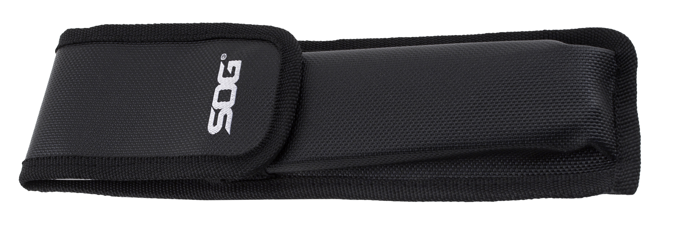
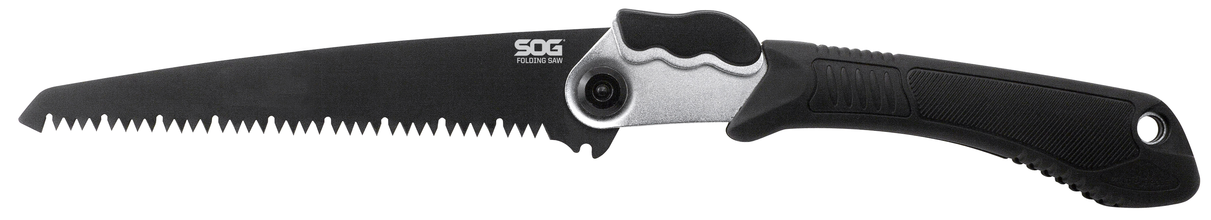
FINISH HARDCASED BLACK
EDGE TYPE SAW
BLADE STEEL TYPE HIGH CARBON STEEL
HANDLE MATERIAL STEEL / KRATON
PRODUCT WEIGHT 5.9 OZ
BLADE LENGTH 8.25”
CLOSED LENGTH 9.5”
OVERALL LENGTH 17.25”
MODEL NUMBER F10N-CP
UPC 729857993357

