FatCat
The FatCat is like our Tomcat after a series of upgrades. As SOG’s largest folder, the FatCat is not intended for the mainstream consumer. It is designed to be exceptional with rare details such as dual tone TiNi (titanium nitride) finished blade. Surprisingly light for its size, the FatCat is also quick and smooth to deploy with either hand using the double thumb studs. The VG-10 blade rotates effortlessly to lock up in SOG’s Arc-Lock. Tested at over 1000 lbs. of force at the lock, the Arc-Lock is SOG’s strongest lock. The handle is made of machined titanium and textured Kraton which make it lightweight and easy to hold.

Key Selling Features:
- Easy one-handed opening and ambidextrous Arc-Lock
- 10.125-inch in length with a 4.5-inch straight edge VG-10 blade
- Satin polished and hardcased black TiNi finished blade
- Machined titanium with molded, textured Kraton handle
- 8.5-Ounce, Lifetime Warranty
- Includes soft nylon case with belt clip
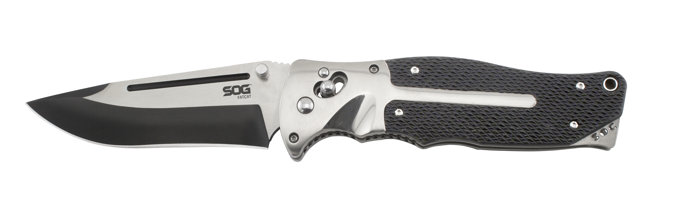
FINISH SATIN POLISHED /
HARDCASED BLACK TINI
BLADE SHAPE CLIP POINT
EDGE TYPE STRAIGHT
BLADE STEEL TYPE VG-10
HANDLE MATERIAL MACHINED TITANIUM / KRATON
HARDNESS RC. 59-60
PRODUCT WEIGHT 8.5 OZ
BLADE LENGTH 4.5”
CLOSED LENGTH 5.625
OVERALL LENGTH 10.125”
MODEL NUMBER FC01-N
UPC 729857991322

