Salute – Bead Blasted
Since our first Fusion tactical folder, we wanted something that was progressive and performance driven. The SOG Salute is an acknowledgment that great design can still be affordable with a little perseverance. For a new, refreshed look, the handles are machined G10 with scalloped full-length steel liners. In addition to the detailed handle, the Salute is completed with a strong lockback mechanism, smooth opening and operation, and a proven Bowie-style blade. To accommodate for different users, the adjustable thumb stud can adapt to various hands and thumbs, allowing the user to find the ideal fit for them. Equipped with a removable low-carry pocket clip, the Salute is a great tactical folder for everyday use.

Key Selling Features:
- Tactical folder for everyday use
- 3.62-inch straight edged 8Cr13MoV blade with bead blasted finish
- Highly durable machined G-10 handle with stainless steel liners
- Lockback design for secure blade lock up
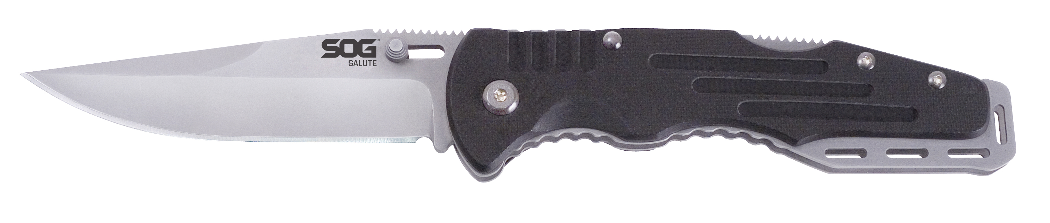
- Overall length: 8.25-inches, Weight: 4.2-ounces, Lifetime Warranty
FINISH BEAD BLASTED
BLADE SHAPE CLIP POINT
EDGE TYPE STRAIGHT
BLADE STEEL TYPE 8CR13MOV
HANDLE MATERIAL G10
HARDNESS RC. 56-58
PRODUCT WEIGHT 4.2 OZ
BLADE LENGTH 3.625”
CLOSED LENGTH 4.625”
OVERALL LENGTH 8.25”
MODEL NUMBER FF10-CP
UPC 729857994361

