Salute – Black
Since our first Fusion tactical folder, we wanted something that was progressive and performance driven. The SOG Salute is an acknowledgment that great design can still be affordable with a little perseverance. For a new, refreshed look, the handles are machined G10 with scalloped full-length steel liners. In addition to the detailed handle, the Salute is completed with a strong lockback mechanism, smooth opening and operation, and a proven Bowie-style blade. To accommodate for different users, the adjustable thumb stud can adapt to various hands and thumbs, allowing the user to find the ideal fit for them. Equipped with a removable low-carry pocket clip, the Salute is a great tactical folder for everyday use.

Key Selling Features:
- Tactical folder for everyday use
- 3.62-inch straight edged 8Cr13MoV blade with hardcased black finish
- Highly durable machined G-10 handle with stainless steel liners
- Lockback design for secure blade lock up
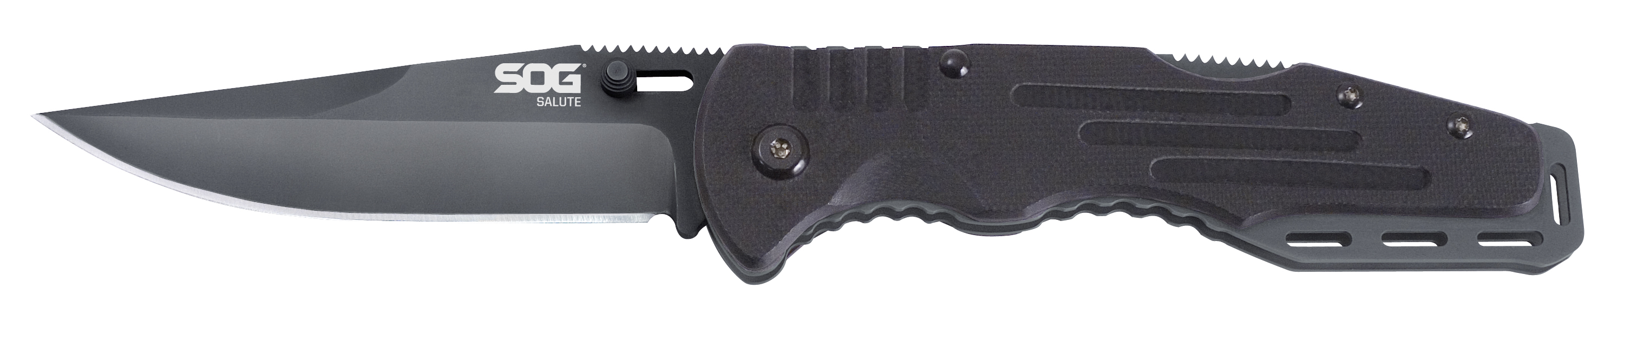
- Overall length: 8.25-inches, Weight: 4.2-ounces, Lifetime Warranty
FINISH HARDCASED BLACK
BLADE SHAPE CLIP POINT
EDGE TYPE STRAIGHT
BLADE STEEL TYPE 8CR13MOV
HANDLE MATERIAL G10
HARDNESS RC. 56-58
PRODUCT WEIGHT 4.2 OZ
BLADE LENGTH 3.625”
CLOSED LENGTH 4.625”
OVERALL LENGTH 8.25”
MODEL NUMBER FF11-CP
UPC 729857994378

