Escape – Black
The SOG Escape can do it all. Equipped with a line cutter, glass breaker, wire stripper, and one-handed opening, the Escape is a perfect knife to stash for emergencies or carry every day. With the escape, you are more prepared for emergencies.

The partially serrated blade opens smoothly and quickly with a push of the thumb and flick of the wrist. When open, the blade locks in place using a strong and time-tested lockback mechanism. Fold the blade back in to use the wire stripper capabilities built into the handle. The handle also employs a line cutter, perfect for cutting cord, string, and belts. There is even an extra blade stored under the handle slab. This is all housed in the hard anodized aluminum handle for durability and weight savings. There’s nothing that the Escape can’t handle.

Key Selling Features:
- Folding pocket knife with line cutter and hardened glass breaker
- Hardcased black 3.40-inch stainless steel partially serrated blade
- Anodized 6061-T6 Aluminum handle with extra cutter blade under the handle cover
- Includes pocket clip and spare cutter blade
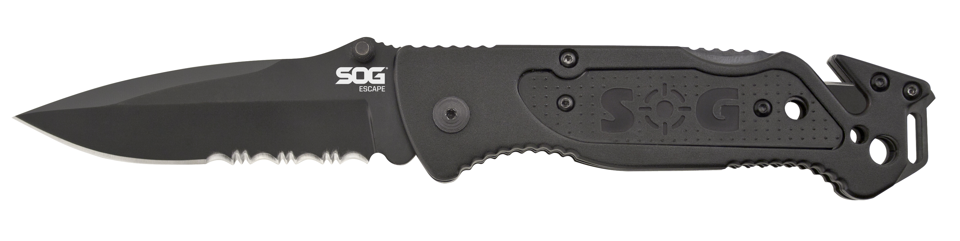
- Overall length: 8.2-inches, Weight: 4.8-ounces, Lifetime Warranty
FINISH HARDCASED BLACK
BLADE SHAPE CLIP POINT
EDGE TYPE PARTIALLY SERRATED
BLADE STEEL TYPE 9CR18MOV
HANDLE MATERIAL ANODIZED ALUMINUM 6061-T6
HARDNESS RC. 58-60
PRODUCT WEIGHT 4.8 OZ
BLADE LENGTH 3.4”
CLOSED LENGTH 4.8”
OVERALL LENGTH 8.2”
MODEL NUMBER FF25-CP
UPC 729857996631

