Fielder XL – Wood
Incorporating a classic look and design, the SOG Fielder series makes a great everyday carry knife even if you are in a suit and tie. The contrast of the vertical grain wood or G10 against the high luster bolsters creates a very appealing visual tension. This is a knife that is comfortable as a daily carry, but can still go out in the wild. Using the proven liner lock system provides reliability as well as easy closing of the Fielder’s capable blade. The blade opens easily and smoothly with the push of a thumb and the flick of one hand. With a removable low-carry pocket clip, the Fielder can find a home in any pocket.

Key Selling Features:
- Classic design with wood handle
- 4.125-inch straight edge 7Cr17 stainless steel blade
- Polished stainless steel bolsters
- Removable low-carry pocket clip
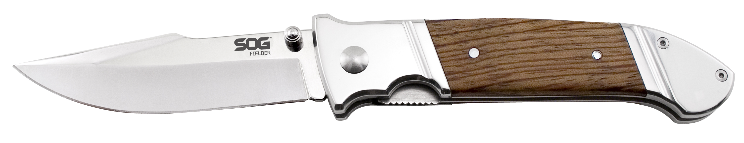
- Overall length: 9.625-inches, Weight: 8.6 ounces, Lifetime Warranty
FINISH MIRROR POLISHED
BLADE SHAPE CLIP POINT
EDGE TYPE STRAIGHT
BLADE STEEL TYPE 7CR17
HANDLE MATERIAL WOOD / STAINLESS STEEL
HARDNESS RC. 52-59
PRODUCT WEIGHT 8.6 OZ
BLADE LENGTH 4.125”
CLOSED LENGTH 5.5”
OVERALL LENGTH 9.625”
MODEL NUMBER FF34-CP
UPC 729857995245

