Forge
The SOG Forge evokes a period in Japanese history when honor was the most highly coveted virtue: it was a time when everything was handmade with meticulous care. A good knife or sword was meant to last for life- and as such, The Forge is built using both traditional and modern methods. It projects a sense of elegance and sophistication at the same time. The VG-10 san mai blade is hammer forged creating the distinctive pattern and the handle is precisely fitted using a stepped topo design for exemplary balance and feel. Because no detail is overlooked, the sheath is as good as the knife - crafted in Japan from thick rich leather with a splash design stitched into its face. The SOG Forge is truly a beautiful collector’s item.

Key Selling Features:
- Fixed blade knife made with traditional and modern methods to last a lifetime
- San Mai (VG-10 Core laminated with 420J2) blade
- Balanced and sculpted glass-reinforced nylon handle
- Leather Sheath
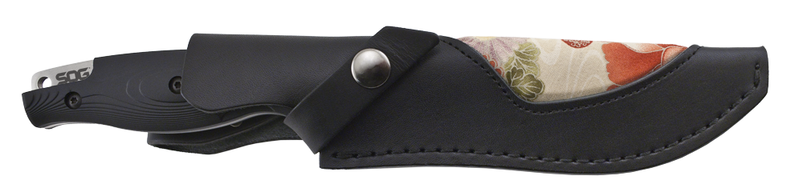
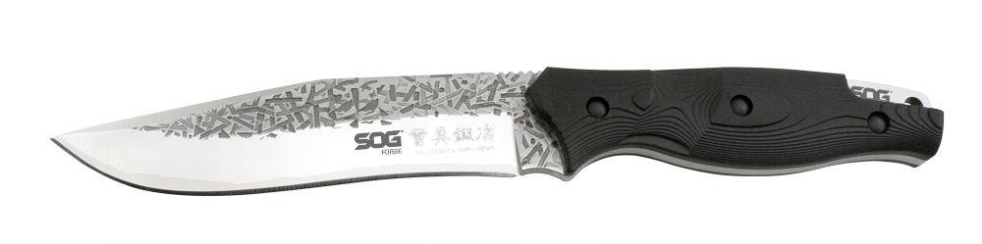
- Overall length: 10.875-inches, Weight: 10.1-ounces, Lifetime Warranty
FINISH SATIN POLISHED
BLADE SHAPE CLIP POINT
EDGE TYPE STRAIGHT
BLADE STEEL TYPE SAN MAI VG-10
HANDLE MATERIAL GLASS-REINFORCED NYLON (GRN)
HARDNESS RC. 59-60
PRODUCT WEIGHT 10.1 OZ
BLADE LENGTH 6.0”
OVERALL LENGTH 10.875”
MODEL NUMBER FG01-L
UPC 729857994811

