Spirit
The SOG Spirit looks like a futuristic tribal spear taking off from 'Area 51'. Sleek and aerodynamic, it hides a secret... Unscrew the handle and use a broom handle* to complete the spear! In a survival situation, use a branch to make the spear shaft and tighten it with a nail or the provided setscrew. With the provided handle the Spirit can be thrown or used as a cutting tool.

Key Selling Features:
- Remove the handle and attached to broom handle for extra reach
- 4.25-inch straight edged black oxide coated 420 stainless steel blade
- Durable glass-reinforced removable nylon handle with set screw
- Nylon carry sheath w/ belt loop
- Overall length: 10.65-inches, Weight: 10-ounces, Lifetime Warranty
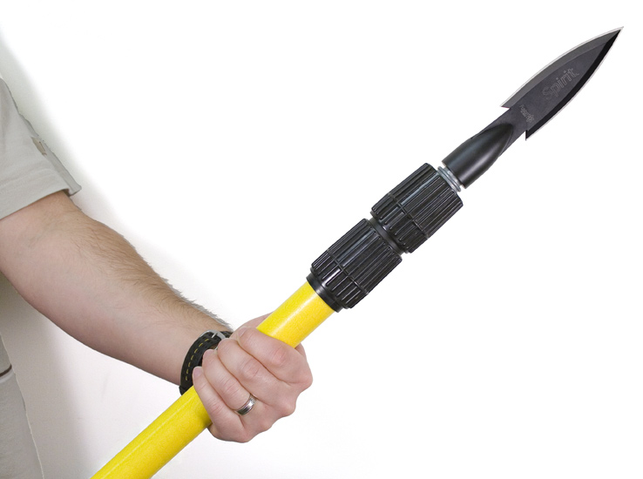
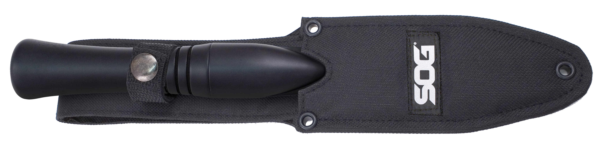
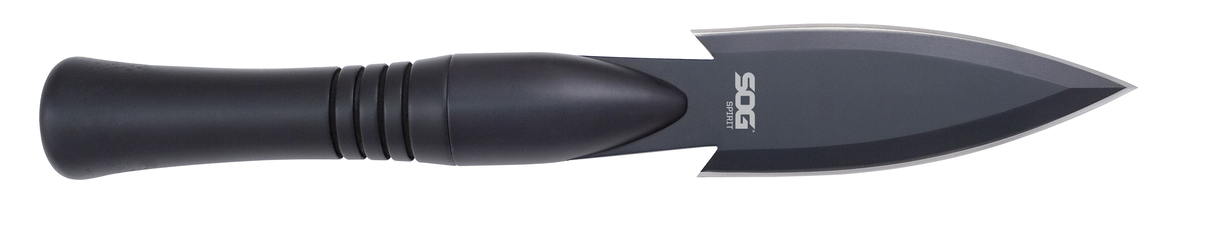
FINISH HARDCASED BLACK
BLADE SHAPE SPEAR
EDGE TYPE STRAIGHT
BLADE STEEL TYPE 420 STAINLESS
HANDLE MATERIAL GLASS-REINFORCED NYLON (GRN)
HARDNESS RC. 51-53
PRODUCT WEIGHT 10.0 OZ
BLADE LENGTH 4.25”
OVERALL LENGTH 10.65”
MODEL NUMBER FS01N-CP
UPC 729857996150

