Flash II – Satin, ½ Serrated
The SOG Flash™ line of folding knives debuted SOG’s patented S.A.T. ™ (SOG Assisted Technology). This mechanism helps propel the blade open once the operator has initiated the one-handed opening action. They open very quickly and lock firmly.

The Flash series employs a powerful piston locking mechanism that can be unlocked with a sliding lever. It features durable and textured glass-reinforced nylon (GRN) handle for slip-resistant use. When not in use, the reversible low-carry pocket clip allows you to stow your knife securely and discreetly. Incorporated into the design is versatile safety lock that helps insure the blade will not open while being carried. Available in a variety of colors, blade shapes & finishes, and sizes; the Flash series makes a great lightweight EDC.

Key Selling Features:
- Quick one-handed opening employing SOG Assisted Technology w/ built in blade safety lock & double thumb studs
- 3.5-inch satin finished partially serrated edge AUS8 stainless steel blade
- Rugged and lightweight black glass-reinforced nylon handle
- Reversible low-carry pocket clip
- Overall length: 8.0-inches, Weight: 3.1-ounces, Lifetime Warranty

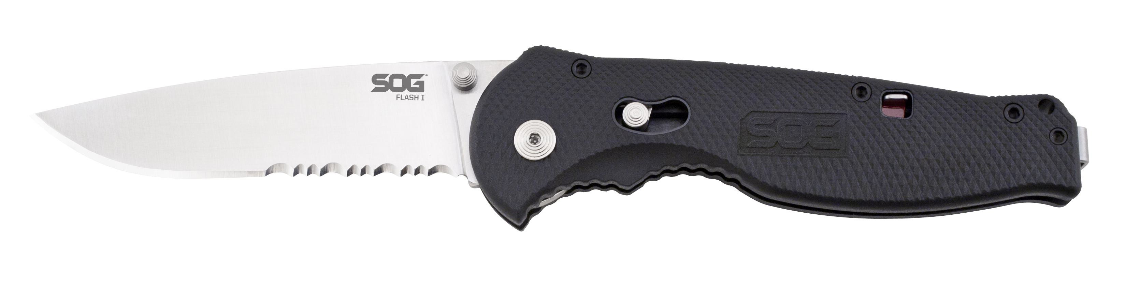
FINISH SATIN POLISHED
BLADE SHAPE DROP POINT
EDGE TYPE PARTIALLY SERRATED
BLADE STEEL TYPE AUS-8
HANDLE MATERIAL GLASS-REINFORCED NYLON (GRN)
HARDNESS RC. 57-58
PRODUCT WEIGHT 3.1 OZ
BLADE LENGTH 3.5”
CLOSED LENGTH 4.5”
OVERALL LENGTH 8.0”
MODEL NUMBER FSA98-CP
UPC 729857994248

