Kiku Folder – Large, Satin
Building upon SOG’s long tradition of honoring Japanese knife makers, SOG and Kiku Matsuda, one of the most famous blade grinders in Japan, collaborated to produce this line of Kiku Folders. After decades of experience in blade grinding and making fixed blade knives, Matsuda, with the production assistance from SOG, designed and created his first folding knife. As one of the foremost tactical knife designers in Japan, Matsuda and SOG have won awards on collaborations before with the SOG Kiku Fixed Blade. The elegant linen micarta handle is rugged and easy to clean, while the AUS-8 stainless steel blade is set up for years of reliable service.

Key Selling Features:
- Rugged yet elegant folding knife made in collaboration with legendary Japanese knife maker, Kiku Matsuda
- 4.6-inch straight edged clip point AUS-8 stainless steel blade in satin polished finish
- Linen Micarta handle with liner lock construction
- Low carry pocket clip
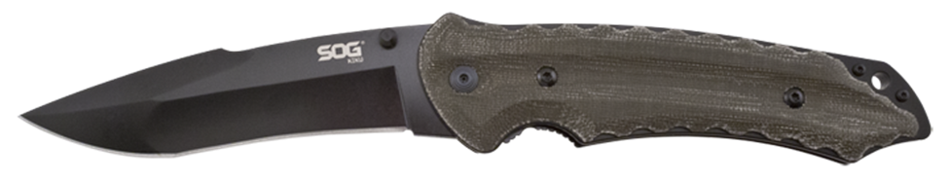
- Overall length: 9.4-inches, Weight: 7.0 ounces, Lifetime Warranty
FINISH SATIN POLISHED
BLADE SHAPE CLIP POINT
EDGE TYPE STRAIGHT
BLADE STEEL TYPE AUS-8
HANDLE MATERIAL LINEN MICARTA
HARDNESS RC. 57-58
PRODUCT WEIGHT 7.0 OZ
BLADE LENGTH 4.6”
CLOSED LENGTH 4.8”
OVERALL LENGTH 9.4”
MODEL NUMBER KU-1011
UPC 729857999700

