Mini X-Ray Vision
Two words that best describe the X-Ray Vision are “tactical” and “practical.” This combo-edged folder features the same blade design as the SOG Vision like using high-end VG-10 steel, but retails at half the price. Created for optimal performance and value, the X-Ray Vision is the newest member of this high-tech family of folding knives. This knife is further enhanced with our revolutionary Arc-Lock™ for fast-access and full "lockup." The X-Ray Vision keeps a low profile with its bead blasted blade finish and black glass-reinforced nylon (GRN) handle to keep it lightweight and comfortable to hold and carry. A reversible low-carry pocket clip allows both righties and lefties to carry the X-Ray Vision conveniently in pocket, pack, or on vest, belt, or jacket.

Key Selling Features:
- Easy one-hand opening and ambidextrous Arc-Lock
- 3.0-inch bead blasted, partially serrated, tanto VG-10 stainless steel blade
- Durable and rugged black glass-reinforced nylon handle with stainless steel liners
- Reversible low-carry pocket clip
- Overall length: 7.0-inches, Weight: 3.0-ounces, Lifetime Warranty

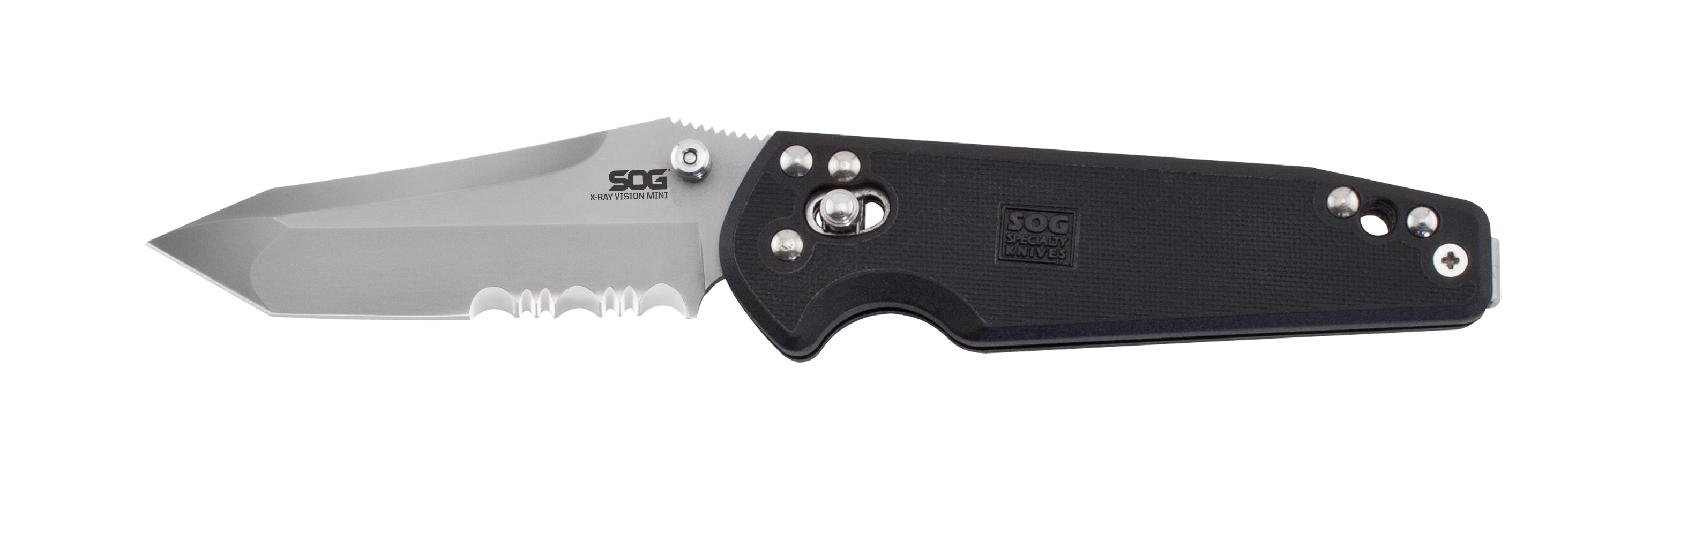
FINISH BEAD BLASTED
BLADE SHAPE TANTO
EDGE TYPE PARTIALLY SERRATED
BLADE STEEL TYPE VG-10
HANDLE MATERIAL GLASS-REINFORCED NYLON (GRN)
HARDNESS RC. 59-60
PRODUCT WEIGHT 3.0 OZ
BLADE LENGTH 3.0”
CLOSED LENGTH 4.0”
OVERALL LENGTH 7.0”
MODEL NUMBER MXV72-CP
UPC 729857994637

