Pentagon Elite II
The Pentagon series sets the policy for action. Designed as backup for military and law enforcement, the Pentagon is the first multipurpose, double-edged knife of its kind. A folding version of the Pentagon, the Pentagon Elite has all the benefits of its big brother as well as a bead blasted blade that reduces reflection. The stainless steel blade offers the instant choice between a serrated or beveled edge, giving you the best of both worlds for cutting virtually any material. Extremely lightweight, the Pentagon Elite features a glass-reinforced GRN handle with stainless steel liners that provides sensational feel and balance. Tested at over 1000 lbs. of force at the lock, the Arc-Lock is SOG’s strongest lock. It can be carried conveniently with its reversible low-carry pocket clip.

Key Selling Features:
- Easy one-handed opening and ambidextrous Arc-Lock
- 5.0-inch bead blasted partially serrated spear point VG-10 stainless steel blade
- Durable and rugged black glass-reinforced nylon handle with stainless steel liners
- Reversible low-carry pocket clip
- Overall length: 10.75-inches, Weight: 6.8-ounces, Lifetime Warranty

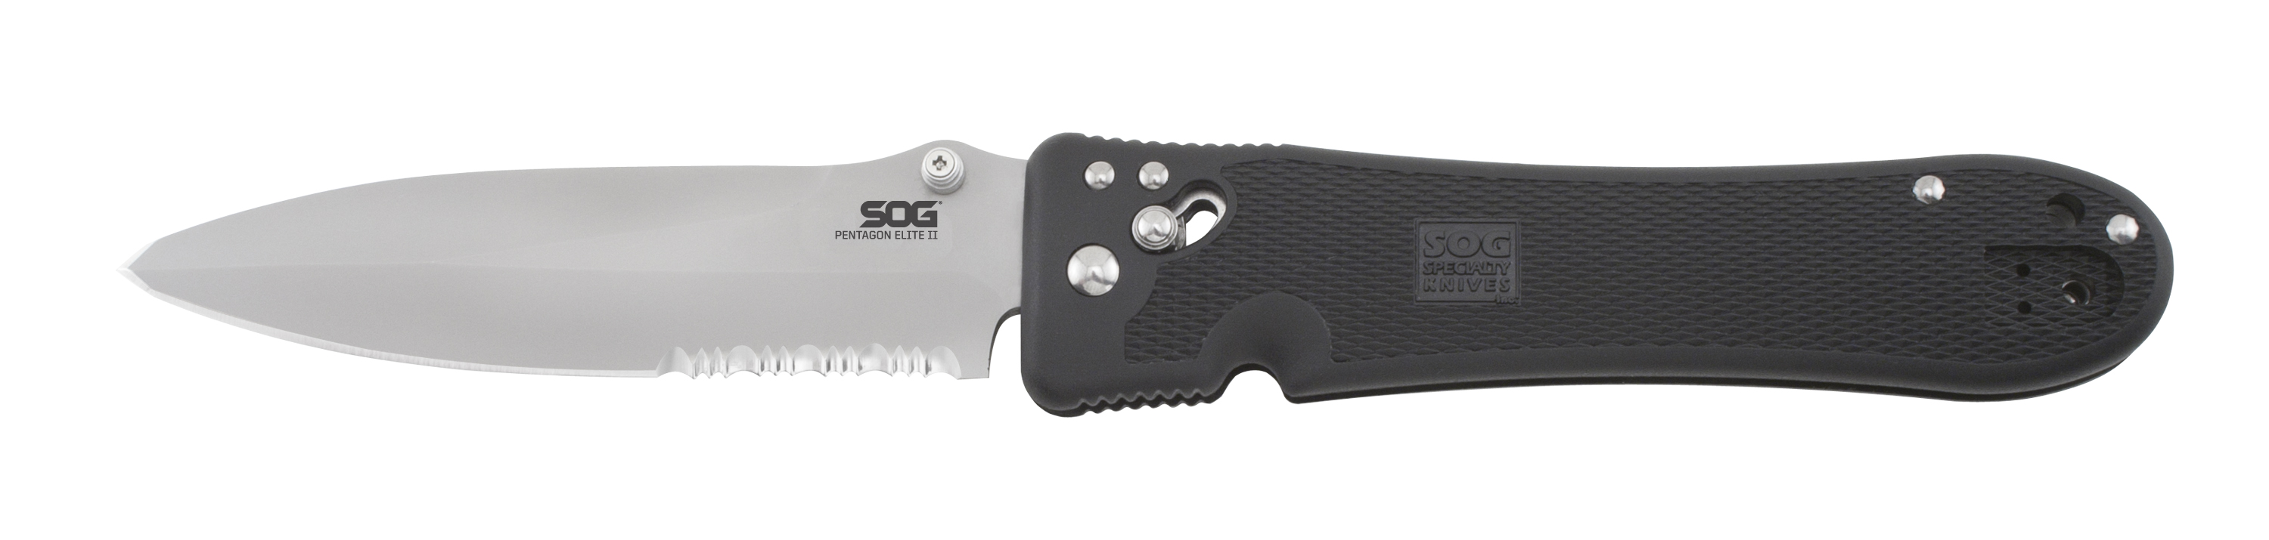
FINISH BEAD BLASTED
BLADE SHAPE SPEAR POINT
EDGE TYPE PARTIALLY SERRATED
BLADE STEEL TYPE VG-10
HANDLE MATERIAL GLASS-REINFORCED NYLON (GRN)
HARDNESS RC. 59-60
PRODUCT WEIGHT 6.8 OZ
BLADE LENGTH 5.0”
CLOSED LENGTH 5.75”
OVERALL LENGTH 10.75”
MODEL NUMBER PE18-ARC
UPC 729857000185

