Pentagon
The Pentagon sets the policy for action. Designed as backup for military and law enforcement, the Pentagon is the first multipurpose, double-edged knife of its kind. The 5.0" stainless steel blade offers the instant choice between a serrated or beveled edge, giving you the best of both worlds for cutting virtually any material. Thumb notches on the blade enable accurate blade orientation and downward control. The flared, wrap-around, checkered Kraton handle provides an optimal grip while maintaining a low profile signature for concealment. The Pentagon comes in a ballistic nylon sheath that is MOLLE-compatible and allows the Pentagon to be mounted in a variety of ways.

Key Selling Features:
- Double edged blade with partially serrated and straight edge
- 5.0-inch double edged satin polished AUS-8 stainless steel blade
- Slip-resistant and comfortable Kraton rubber handle
- MOLLE-compatible ballistic nylon sheath
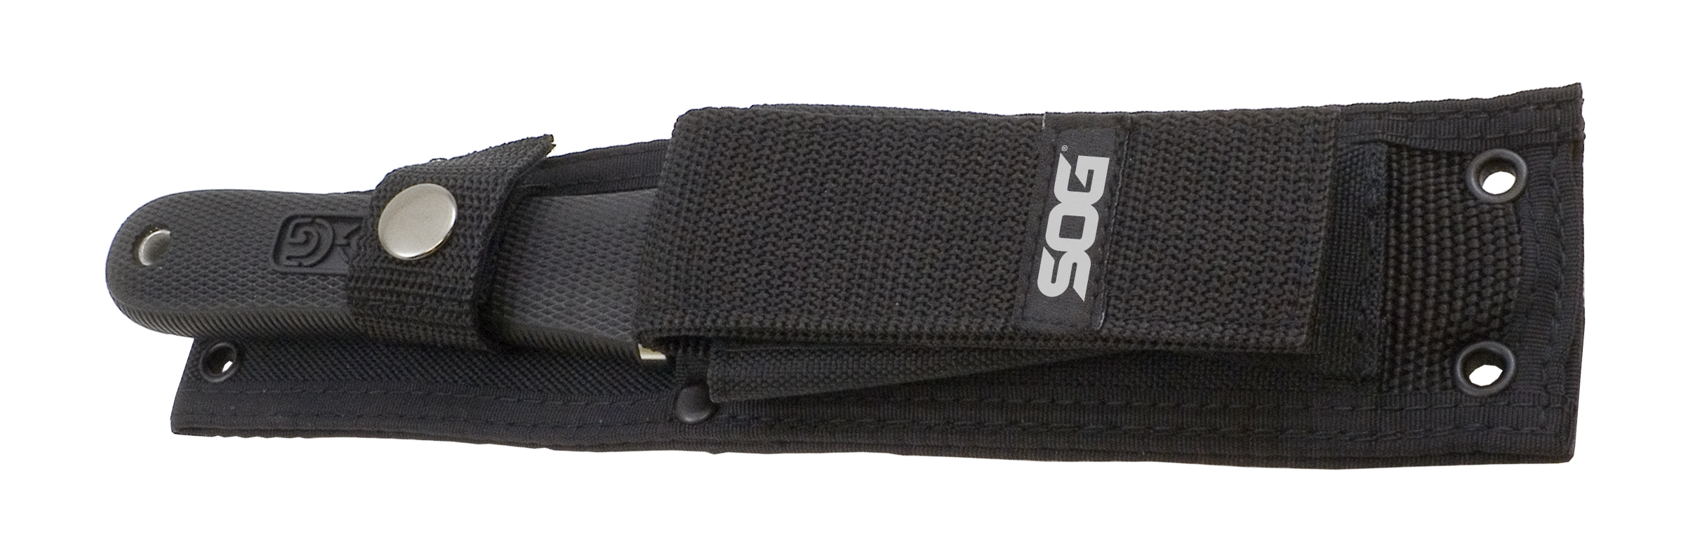
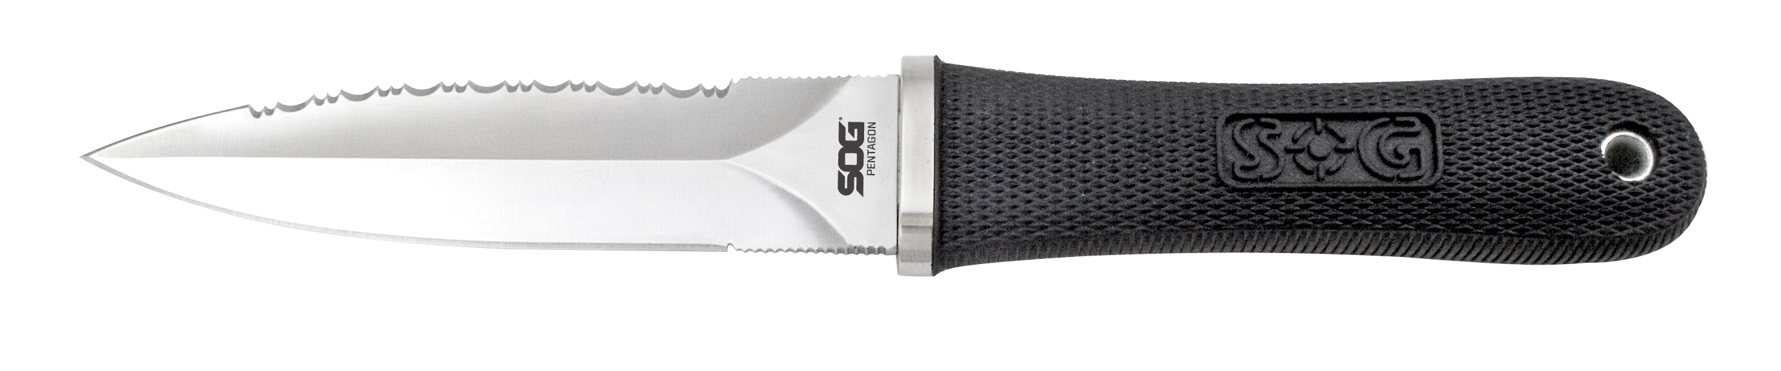
- Overall length: 9.75 -inches, Weight: 5.6-ounces, Lifetime Warranty
FINISH SATIN POLISHED
BLADE SHAPE DAGGER
EDGE TYPE STRAIGHT / PARTIALLY SERRATED
BLADE STEEL TYPE AUS-8
HANDLE MATERIAL KRATON RUBBER
HARDNESS RC. 57-58
PRODUCT WEIGHT 5.6 OZ
BLADE LENGTH 5.0”
OVERALL LENGTH 9.75”
MODEL NUMBER S14-N
UPC 729857000147

