SOG Bowie 2.0
The original SOG Bowie that founded our company was based on a knife used by the Studies and Observation Group of the US Special Forces and other elite soldiers in the Vietnam War. The SOG Bowie 2.0 has combined the traditional SOG Bowie with modern technology and materials. As a top-notch working knife, it benefits form hardcased black TiNi coatings and AUS-8 steel. The SOG Bowie 2.0 has become a classic that is unparalleled in quality. The sculpted crossguard, deep hollow grinds and precision detailing, and faceted tip are unmistakable signatures.

Key Selling Features:
- Modern replica of the original SOG Bowie knife that founded the company
- 6.4-inch straight edge hardcased black TiNi AUS-8 stainless steel blade
- Epoxied stacked leather washer handle
- Leather sheath with sharpening stone
- Overall length: 11-inches, Weight: 11.2-ounces, Lifetime Warranty
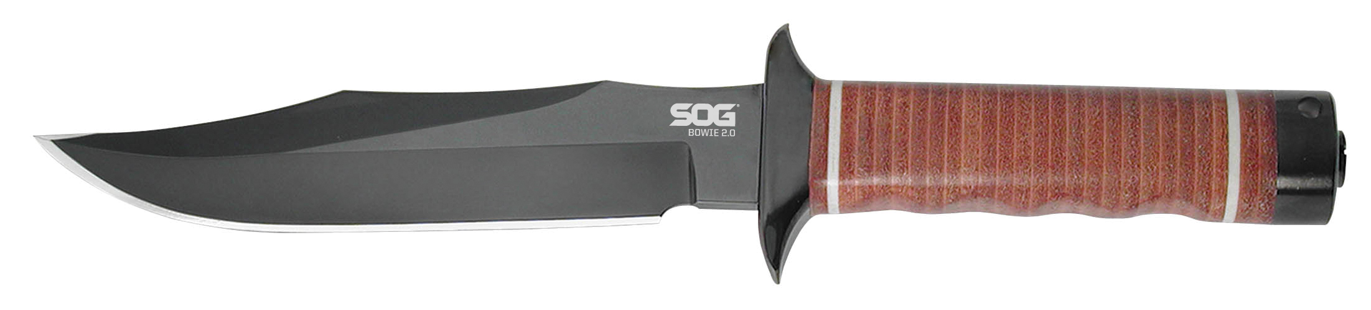
FINISH HARDCASED BLACK TINI
BLADE SHAPE CLIP POINT
EDGE TYPE STRAIGHT
BLADE STEEL TYPE AUS-8
HANDLE MATERIAL STACKED EPOXIED LEATHER WASHERS
HARDNESS RC. 57-58
PRODUCT WEIGHT 11.2 OZ
BLADE LENGTH 6.4”
OVERALL LENGTH 11.0”
MODEL NUMBER S1T-L
UPC 729857990295

