Pocket PowerPlier
Lighter and more compact than its big brother, the PowerPlier, the Pocket PowerPlier is easy to carry and use. SOG's Pocket PowerPlier is packed with essential tools that comes with a heavy duty nylon or leather pouch. Exclusive interlocking gears are the driving force behind SOG's renowned PowerPlier Series. They allow these amazing multi-tools to be opened with a one-handed flip of the wrist and also generates Compound Leverage action that doubles the pliers gripping power. These gears also allow the pliers to be easily flipped open with one hand so your tool is ready to act quickly.

Key Selling Features:
- Exclusive patented Compound Leverage generates twice the gripping power.
- Satin polished stainless steel handles and plier head
- Total Components: 13
- Open: 6-inches, Closed: 4-inches, Weight: 5.5-ounces, Lifetime Warranty
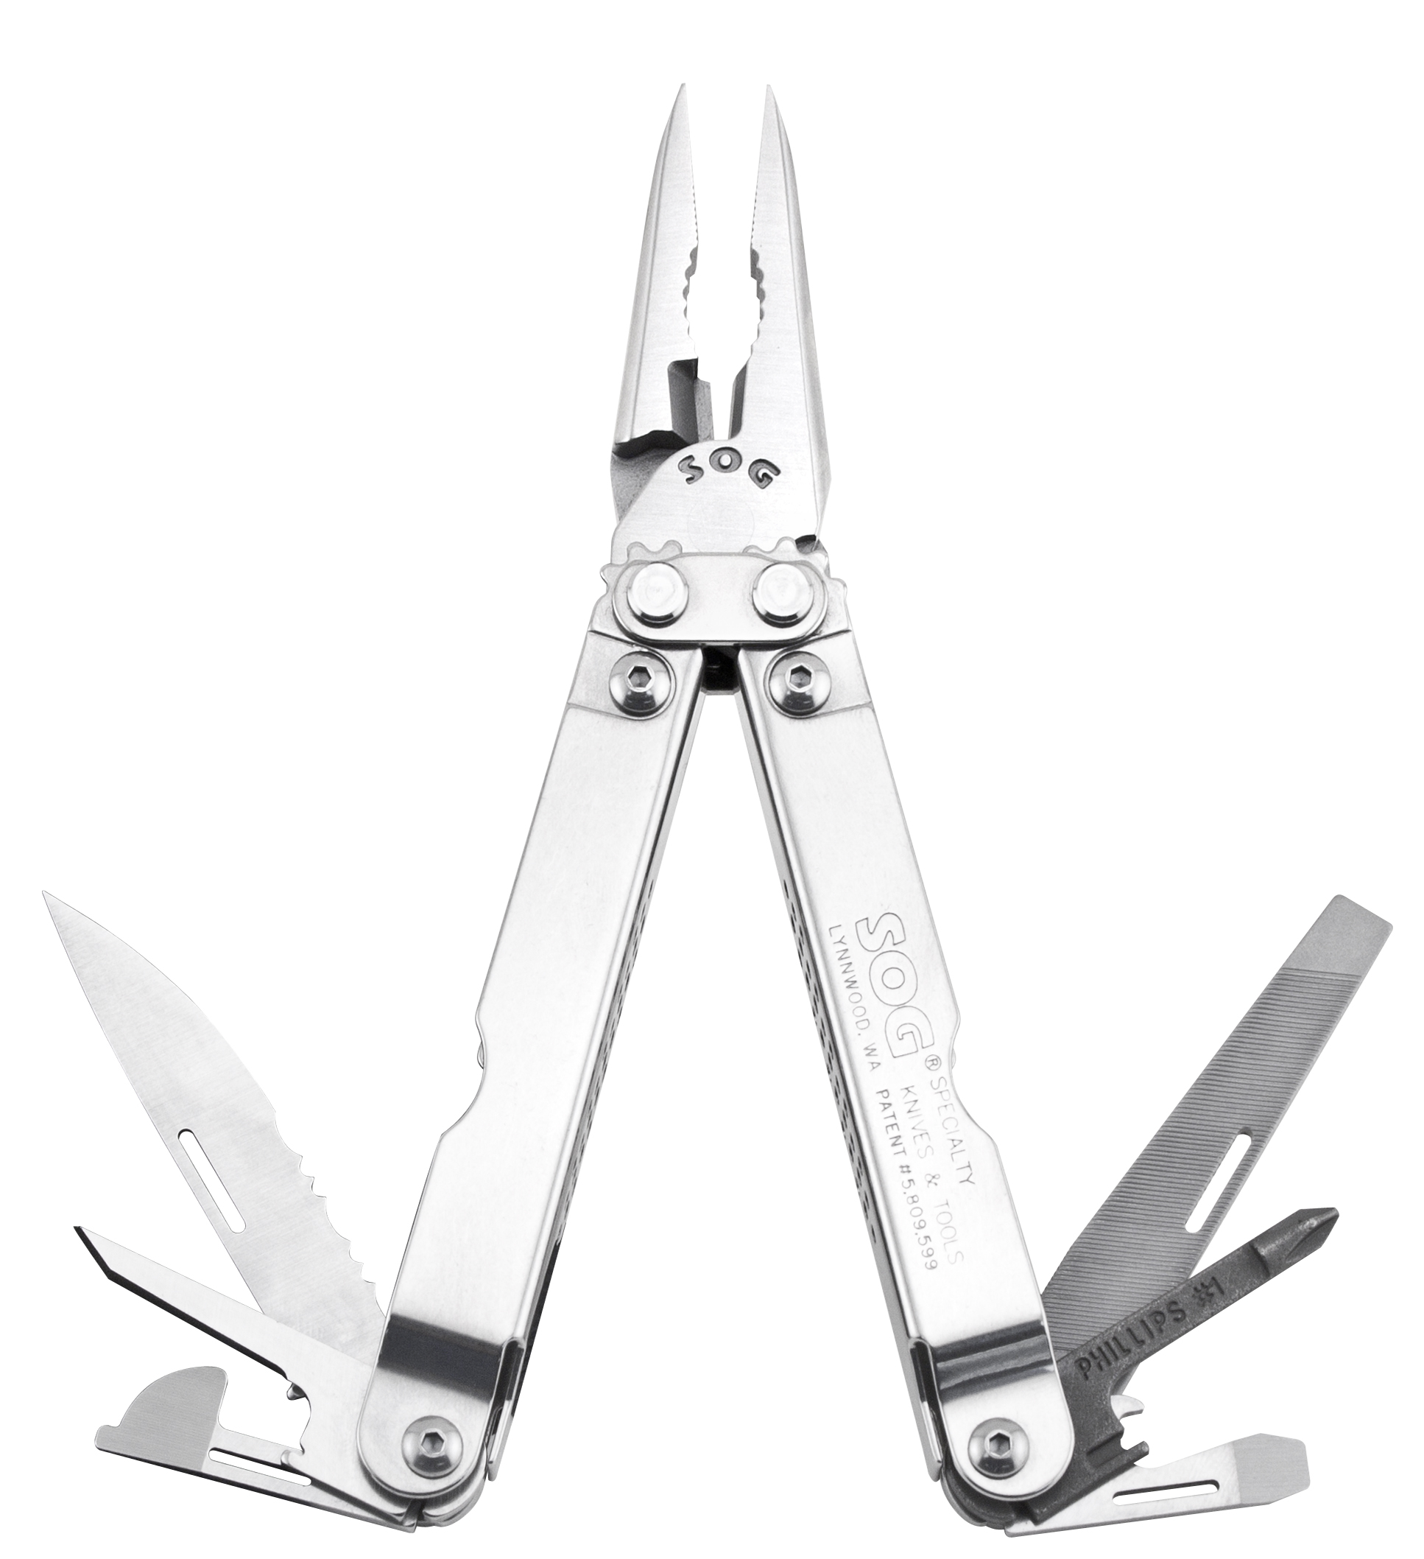
- Comes with nylon (S44-N) or leather (S44-L) carry pouch
FINISH SATIN POLISHED
STEEL TYPE 420 STAINLESS
HANDLE MATERIAL 420 STAINLESS
TOOLS NEEDLE NOSE PLIERS
HARD WIRE CUTTER
3-SIDED FILE
AWL
BOLT GRIP CHANNEL
BOTTLE OPENER
CAN OPENER
½ SERRATED BLADE
SLOTTED SCREWDRIVERS (S/M/L)
PHILLIPS SCREWDRIVER
RULER
PRODUCT WEIGHT 5.5 OZ
CLOSED LENGTH 4.0”
OVERALL LENGTH 6.0”
MODEL NUMBER S44-N/S44-L
UPC 729857000444/729857992251

