PowerLock – V-Cutter
The PowerLock’s success over the years has been documented by countless testimonials. It is our workhorse and the center for our entire multi-tool line. Flip opening, locking components, gear covers, auxiliary handle covers, and hex construction are all standard.

As one of the original multi-tool manufacturers, we have learned quite a bit over the years, like how to make the toughest tools with patented gear driven Compound Leverage™ mechanisms. We know that quick access is a must. Just flip our tools out with one hand and the pliers are ready for action. Versatility in the field is a necessity and heavy duty construction provides access. There is also a myriad of features that you might not readily see, like our saws, files, and other tools.

Key Selling Features:
- Exclusive patented Compound Leverage generates twice the gripping power
- Satin polished stainless steel handles and plier head.
- Total Components: 22
- Features individually locking components
- Open: 7-inches, Closed: 4.6-inches, Weight: 9.6-ounces, Lifetime Warranty
- Includes leather (S62-L) or nylon (S62N-CP) carry pouch
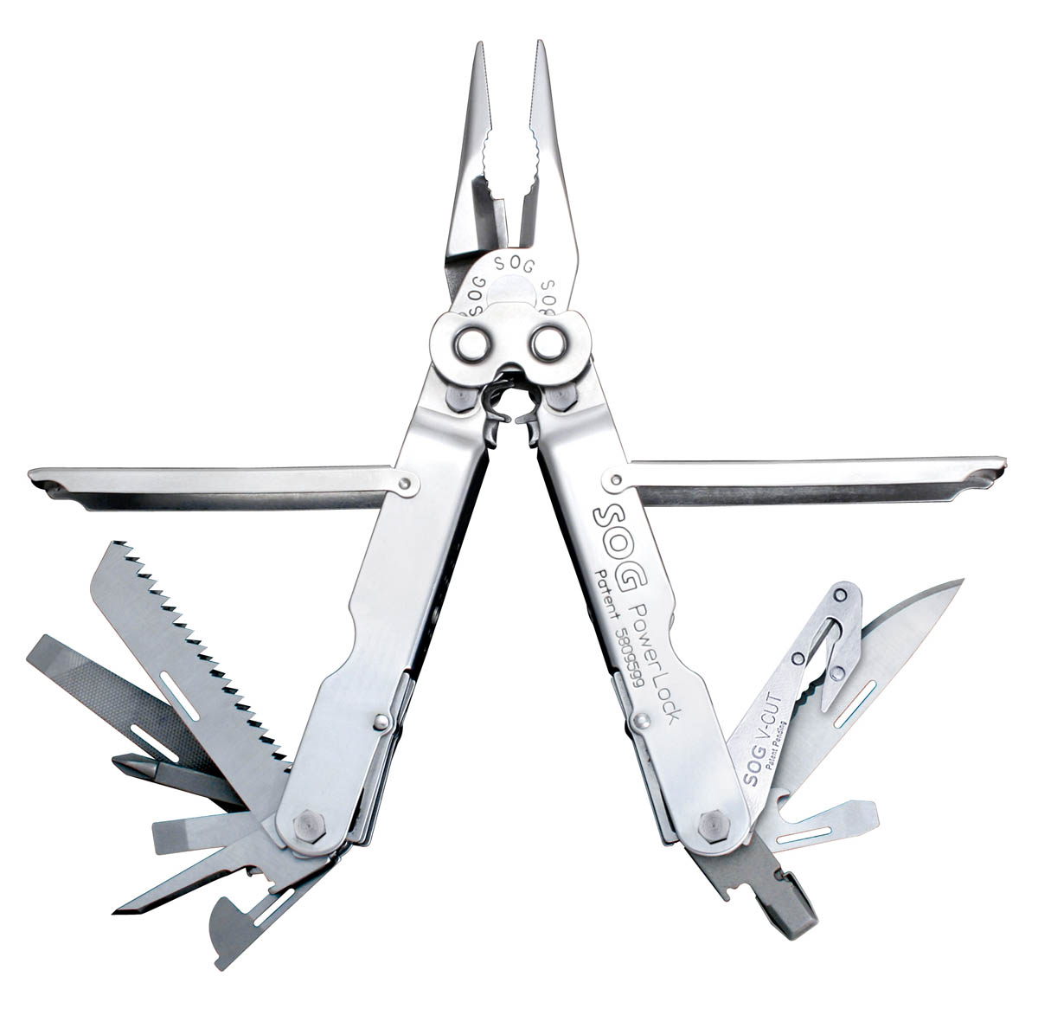
FINISH SATIN POLISHED
STEEL TYPE 420 STAINLESS
HANDLE MATERIAL 420 STAINLESS
TOOLS NEEDLE NOSE PLIERS
HARD WIRE CUTTER
BOLT GRIP CHANNEL
BOTTLE OPENER
CAN OPENER
½ SERRATED BLADE
WOOD SAW
¼” DRIVE
3-SIDED FILE
AWL
BLASTING CAP CRIMPER
WIRE CRIMPER
V-CUTTER
SLOTTED SCREWDRIVERS (S/M/L)
PHILLIPS SCREWDRIVER
RULER
PRODUCT WEIGHT 9.6 OZ
CLOSED LENGTH 4.6”
OVERALL LENGTH 7.0”
MODEL NUMBER S62-L / S62N-CP
UPC 729857992336 / 729857993968

