PowerAssist
The new PowerAssist takes multi-tools to a new level. This is the first in the world to house not just one but two SOG Assisted Technology™ blades. Start to open the main blades, which are available when the main tool is closed, and S.A.T. takes over to complete opening. When not in use, these blades lock closed using our patent pending side release. Flip open the tool and experience the precision of the heavy-duty plier capability and large wire cutters. Smooth handle surfaces promote comfort on even the toughest jobs.

Key Selling Features:
- Exclusive SOG Assisted Technology blades (straight and serrated) and compound leverage generates twice the gripping power
- Satin polished stainless steel handles and plier head
- Total tools: 22
- Open: 7.0-inches, Closed: 4.6-inches, Weight: 9.6-ounces, Lifetime Warranty
- Includes leather (S66-L) or nylon (S66N-CP) carry pouch
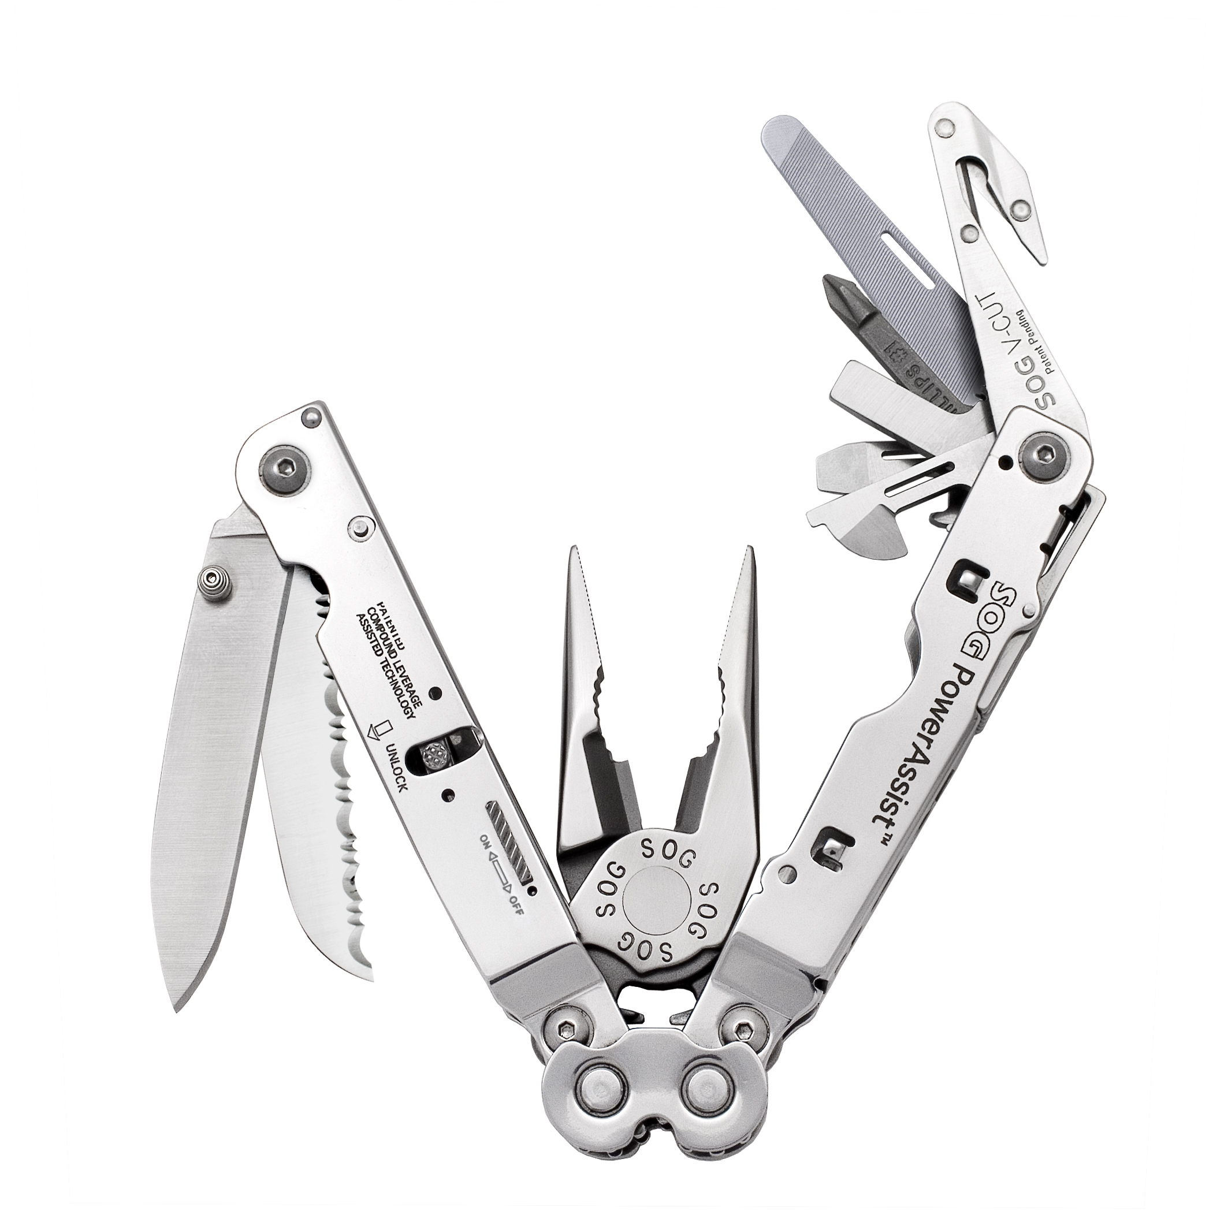
FINISH SATIN POLISHED
STEEL TYPE 420 STAINLESS
HANDLE MATERIAL 420 STAINLESS
TOOLS NEEDLE NOSE PLIERS
HARD WIRE CUTTER
BOLT GRIP CHANNEL
BOTTLE OPENER
CAN OPENER
FULL SERRATED BLADE
STRAIGHT EDGE BLADE
3-SIDED FILE
BLASTING CAP CRIMPER
WIRE CRIMPER
V-CUTTER
SLOTTED SCREWDRIVERS (S/M/L)
PHILLIPS SCREWDRIVER
RULER
PRODUCT WEIGHT 9.6 OZ
CLOSED LENGTH 4.6”
OVERALL LENGTH 7.0”
MODEL NUMBER S66-L / S66N-CP
UPC 729857992275 / 729857993999

