TomCat 3.0
SOG’s first folding knife, the first generation Tomcat, set the standard for the large format lockback folders and won the award for Overall Knife of the Year in 1988. Today the redesigned TomCat 3.0 will still win a place in your hand. Like a modern day tank, this heavy duty folder is big time armament but has the finesse to turn on a dime. The TomCat 3.0 features our Arc-Lock that combines speed and safety in controlling the big 3.75-inch blade. Surprisingly light for its size, the TomCat 3.0 is also quick and smooth to deploy with either hand using the double thumb studs. The VG-10 blade rotates effortlessly to lock up in SOG’s Arc-Lock. Tested at over 1000 lbs. of force at the lock, the Arc-Lock is SOG’s strongest lock. The handle is made of stainless steel and textured Kraton which make it lightweight and easy to hold.

Key Selling Features:
- Easy one-hand opening and ambidextrous Arc-Lock
- 3.75-inch satin polished straight edge VG-10 stainless steel blade
- Kraton rubber handle with stainless steel bolsters and liners
- Includes black nylon carry pouch
- Overall length: 8.65-inches, Weight: 6.5-ounces, Lifetime Warranty
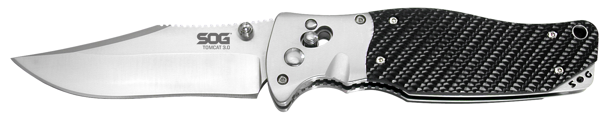
FINISH SATIN POLISHED
BLADE SHAPE CLIP POINT
EDGE TYPE STRAIGHT
BLADE STEEL TYPE VG-10
HANDLE MATERIAL STAINLESS STEEL / KRATON
HARDNESS RC. 59-60
PRODUCT WEIGHT 6.5 OZ
BLADE LENGTH 3.75”
CLOSED LENGTH 4.9
OVERALL LENGTH 8.65”
MODEL NUMBER S95-N
UPC 729857990639

