Spec Elite II Auto – Black TiNi
“Just good enough” and “too fast” are not words in our vocabulary. Producing top-of-the-line products for professionals is what we do. The Spec Elite series is one go-to blade when things get serious.

Like the Pentagon series, the Spec Elite series is designed as a backup and go-to tool for military and law enforcement personnel. Instead of a partially serrated spear point blade, the Spec Elite employs a clip point blade with a straight edge made in high quality AUS-8 steel. Extremely lightweight, the Spec Elite Auto features a hard anodized machined aluminum handle that provides sensational feel and balance. The Spec Elite Auto is an automatic knife intended for military and law enforcement. It can be carried conveniently with its reversible low-carry pocket clip.

Key Selling Features:
- Automatic knife designed for Military and LE Personnel
- 4.0-inch straight edge AUS-8 stainless steel blade
- Hard Anodized Machined Aluminum Handle
- Reversible low-carry pocket clip
- Overall length: 8.9-inches, Weight: 3.6 ounces, Lifetime Warranty

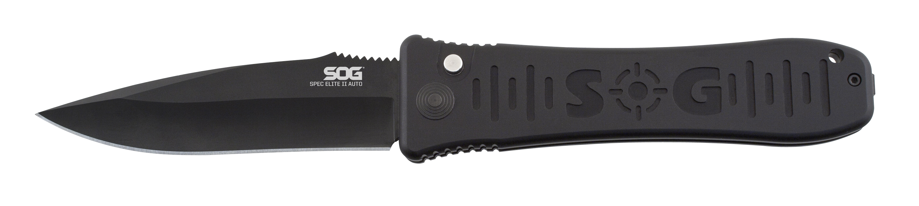
FINISH HARDCASED BLACK TINI
BLADE SHAPE CLIP POINT
EDGE TYPE STRAIGHT
BLADE STEEL TYPE AUS-8
HANDLE MATERIAL ANODIZED ALUMINUM 6061-T6
HARDNESS RC. 57-58
PRODUCT WEIGHT 3.6 OZ
BLADE LENGTH 4.0”
CLOSED LENGTH 4.9”
OVERALL LENGTH 8.9”
MODEL NUMBER SE-62
UPC 729857995764

