Spec Elite II
“Just good enough” and “too fast” are not words in our vocabulary. Producing top-of-the-line products for professionals is what we do. The Spec Elite series is one go-to blade when things get serious.

Description: Like the Pentagon series, the Spec Elite series is designed as a backup and go-to tool for military and law enforcement personnel. Instead of a partially serrated spear point blade, the Spec Elite employs a clip point blade with a straight edge made in high quality VG-10 steel. Extremely lightweight, the Spec Elite features a hard anodized machined aluminum handle that provides sensational feel and balance. The strong Arc-Lock mechanism can hold over 1000 lbs. of force at the pivot. It can be carried conveniently with its reversible low-carry pocket clip.

Key Selling Features:
- Easy one-handed opening and ambidextrous Arc-Lock
- 5.0-inch bead blasted straight edge VG-10 stainless steel blade
- Durable and rugged black glass-reinforced nylon handle with stainless steel liners
- Reversible low-carry pocket clip
- Overall length: 10.75-inches, Weight: 7.1-ounces, Lifetime Warranty

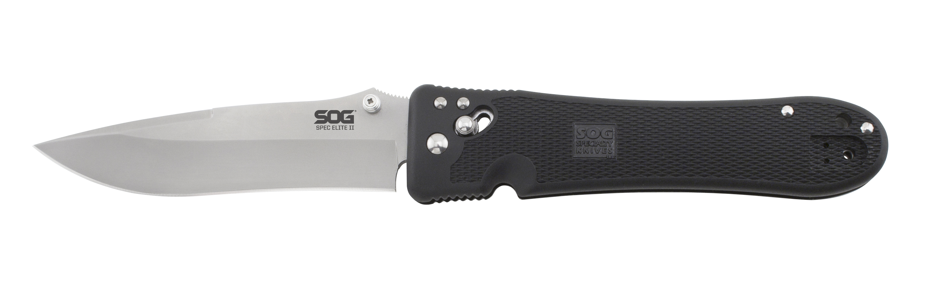
FINISH BEAD BLASTED
BLADE SHAPE CLIP POINT
EDGE TYPE STRAIGHT
BLADE STEEL TYPE VG-10
HANDLE MATERIAL GLASS-REINFORCED NYLON (GRN)
HARDNESS RC. 59-60
PRODUCT WEIGHT 7.1 OZ
BLADE LENGTH 5.0”
CLOSED LENGTH 5.75”
OVERALL LENGTH 10.75”
MODEL NUMBER SE18
UPC 729857990622

