Force
The first thing that is obvious about the Force is how stout and built it is. The thick blade and minimal grind profiles maximize the strength of the blade. Virtually unbreakable, the full tang runs out the back of the glass-reinforced handle and into a glass breaking point. The handle is perfectly contoured and covered in aggressive checkering for improved grip in inclement weather. The Force is designed for extreme, long operations.

Key Selling Features:
- Ultra thick blade designed for wilderness survival and heavy duty use
- 6.0-inch straight edge AUS8 stainless steel blade with black TiNi coating
- Textured Glass-reinforced Nylon handle
- Ballistic Nylon Sheath w/ belt loop
- Overall length: 11.25-inches, Weight: 10.5 ounces, Lifetime Warranty
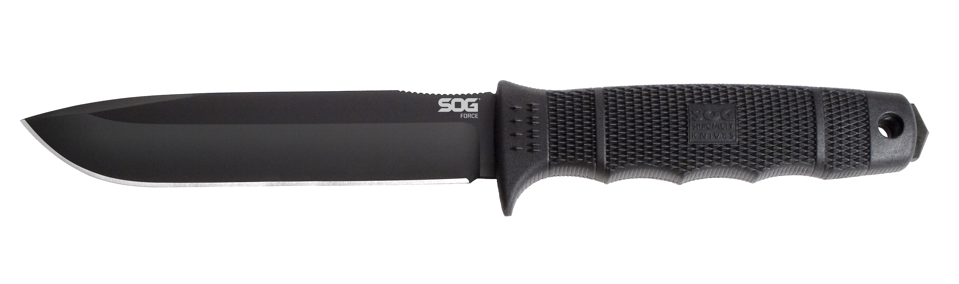
FINISH HARDCASED BLACK TINI
BLADE SHAPE CLIP POINT
EDGE TYPE STRAIGHT
BLADE STEEL TYPE AUS-8
HANDLE MATERIAL GLASS-REINFORCED NYLON (GRN)
HARDNESS RC. 57-58
PRODUCT WEIGHT 10.5 OZ
BLADE LENGTH 6.0”
OVERALL LENGTH 11.25”
MODEL NUMBER SE38-N
UPC 729857992183

