SlimJim XL – Satin, Clip Point
The SOG SlimJim series stands out due to its simplicity and industrial design. The minimalistic construction of the SlimJim make it the thinnest assisted opening knife available. The thin profile is unobtrusive but still strong and durable. Employing SOG Assisted Technology (S.A.T. ™), it opens quickly with a push of a thumb with either hand on the double thumb studs. The handle has tactile bumps to aid user control. When in use, the built-in safely lock can lock the blade open. When not in use, the built-in safety lock ensures there is no unwanted opening. The reversible low-carry pocket clip keeps the SlimJim close by when needed.

Key Selling Features:
- SOG Assisted Technology (S.A.T.) for quick one-handed opening in a ultra-thin handle design
- Satin polished 4.18-inch AUS-8 stainless steel straight edge blade
- Bead blasted stainless steel handle with blade locking safety
- Reversible low-carry pocket clip
- Overall length: 9.36-inches, Weight: 2.7-ounces, Lifetime Warranty

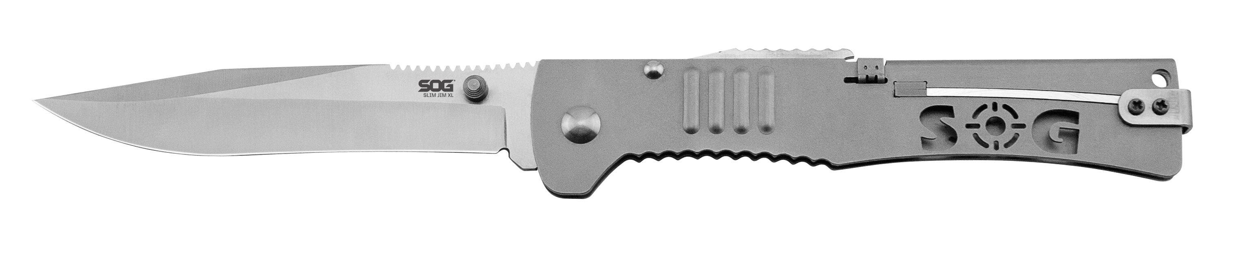
FINISH SATIN POLISHED
BLADE SHAPE CLIP POINT
EDGE TYPE STRAIGHT
BLADE STEEL TYPE AUS-8
HANDLE MATERIAL 420 STAINLESS STEEL
HARDNESS RC. 57-58
PRODUCT WEIGHT 2.4 OZ
BLADE LENGTH 4.18”
CLOSED LENGTH 5.18”
OVERALL LENGTH 9.36”
MODEL NUMBER SJ51-CP
UPC 729857997102

