SOG-TAC Automatic – Black TiNi, Drop, Straight
Like the Pentagon and Spec Elite series, the SOG-TAC series is designed as a backup and go-to tool for military and law enforcement personnel. For years, we have been asked to produce a tactical switchblade. After vigorous design, engineering, and testing, the SOG-TAC is born. The SOG-TAC is an invigorating new design is big, but relatively slim, and specifically tailored to the professional tactical users. The blade travels very fast and once open, it locks up very securely. The 6061-T6 hard-anodized aluminum handle is machined with insets for increased grip and control. It has a safety button that can either lock the blade in the open or closed position. The SOG-TAC should go with you everywhere with the reversible low-carry clip.

Key Selling Features:
- Automatic knife designed for Military and law enforcement personnel use
- 3.5-inch straight edge hardcased black TiNi AUS-8 stainless steel blade
- Hard anodized machined aluminum handle
- Reversible low-carry pocket clip
- Overall length: 8-inches, Weight: 4.5 ounces, Lifetime Warranty

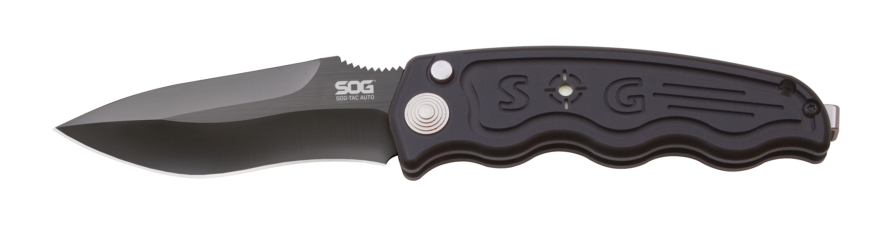
FINISH HARDCASED BLACK TINI
BLADE SHAPE DROP POINT
EDGE TYPE STRAIGHT
BLADE STEEL TYPE AUS-8
HANDLE MATERIAL ANODIZED ALUMINUM 6061-T6
HARDNESS RC. 57-58
PRODUCT WEIGHT 3.8 OZ
BLADE LENGTH 3.5”
CLOSED LENGTH 4.5”
OVERALL LENGTH 8.0”
MODEL NUMBER ST-06
UPC 729857993371

