Trident – Black TiNi, ½ Serrated, Clip, Digi Camo
Designed to tackle any situation, the SOG Trident series is ready to go at a moment’s notice with its assisted opening mechanism, slot cutter, and durable AUS-8 stainless steel blade. Borrowing elements from our original SOG Bowie, Tomcat, SEAL PUP, and Flash; the Trident fits right into the SOG lineup.

SOG’s patented Assisted Technology (S.A.T. ™) enables the user to open the knife quickly with any hand using the double thumb studs. Built into the handle is the slot cutter that can cut thin rope, belts, or webbing without opening the blade. The Trident series employ blades made of reliable AUS-8 and handles made of textured and durable glass-reinforced nylon.

In use, the Arc-Actuator™ blade lock is tough yet easy to open. When the blade is closed, the built-in safety lock can keep unwanted openings while being carried using the reversible low-carry pocket clip. The extremely versatile Trident is available in a variety of sizes, blade shapes, and blade finishes.

Key Selling Features:
- Quick one-hand opening with SOG Assisted Technology and built-in safety
- 3.75-inch hardcased black TiNi partially serrated edge AUS-8 stainless steel blade
- Textured glass-reinforced nylon handle
- Built-in slot cutter
- Reversible low-carry pocket clip
- Overall length: 8.5-inches, Weight: 3.6-ounces, Lifetime Warranty

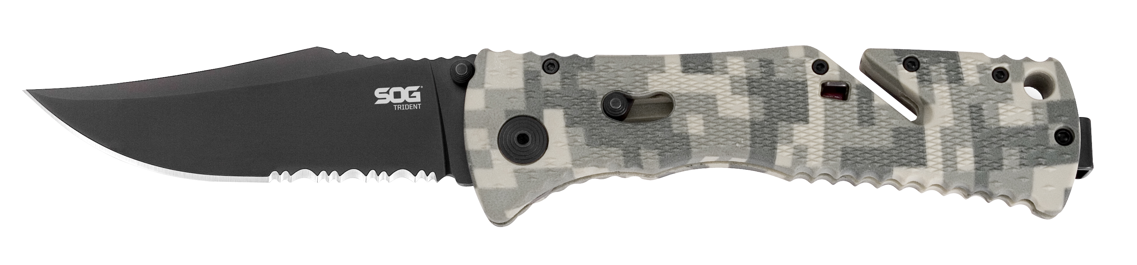
FINISH HARDCASED BLACK TINI
BLADE SHAPE CLIP POINT
EDGE TYPE PARTIALLY SERRATED
BLADE STEEL TYPE AUS-8
HANDLE MATERIAL GLASS-REINFORCED NYLON (GRN)
HARDNESS RC. 56-58
PRODUCT WEIGHT 3.6 OZ
BLADE LENGTH 3.75”
CLOSED LENGTH 4.75
OVERALL LENGTH 8.5”
MODEL NUMBER TF10-CP
UPC 729857994521

